1. **DATA MANAGEMENT:**

**1.1 TimeSeries**

**Pricing Options:**

**Tiered Pricing**

|  |  |  |  |  |  |  |  |
| --- | --- | --- | --- | --- | --- | --- | --- |
| **Feature** | **Unit** | **Tier 1** | | **Tier 2** | **Tier 3** | **Tier 4** | **Tier 5** |
| **Data points** | per million data points | 0 - 10 | | 11 - 125 | 126 - 500 | 501 - 1,000 | > 1,001 |
|  |  | $4.0 | | $3.39 | $3.22 | $3.13 | $1.39 |
| **Concurrent connections** | | per connection | 0 - 10 | 11 - 50 | | 51 - 125 | 126 - 500 | > 500 | |
|  | |  | $5.0 | $4.8 | | $4.5 | $4.3 | $4.1 | |

The Time Series service now accepts compressed (GZIP) JSON payloads. The size limit for the actual JSON payload is 512 KB regardless of the ingestion request format. For compressed payloads, this means that the decompressed payload cannot exceed 512 KB.

You can use mixed data types, including null and string in data ingestion.

The Time Series service provides an **attributes** field to include additional relevant details about that specific data point, such as units or site, for example, "Site":"SanFrancisco".

**Time Series service is controlled by the designated trusted issuer and is managed by the User Account and Authentication (UAA) web service.

## [Time Series](https://www.predix.io/services/service.html?id=1177#!/Time_Series)

### [GET](https://www.predix.io/services/service.html?id=1177#!/Time_Series/getAggregationNames) [/v1/aggregations](https://www.predix.io/services/service.html?id=1177#!/Time_Series/getAggregationNames)

* + - * [Get all available aggregations](https://www.predix.io/services/service.html?id=1177#!/Time_Series/getAggregationNames)

### [GET](https://www.predix.io/services/service.html?id=1177#!/Time_Series/query) [/v1/datapoints](https://www.predix.io/services/service.html?id=1177#!/Time_Series/query)

* + - * [Query Datapoints](https://www.predix.io/services/service.html?id=1177#!/Time_Series/query)

### [POST](https://www.predix.io/services/service.html?id=1177#!/Time_Series/get) [/v1/datapoints](https://www.predix.io/services/service.html?id=1177#!/Time_Series/get)

* + - * [Query Datapoints](https://www.predix.io/services/service.html?id=1177#!/Time_Series/get)

### [GET](https://www.predix.io/services/service.html?id=1177#!/Time_Series/queryCurrent) [/v1/datapoints/latest](https://www.predix.io/services/service.html?id=1177#!/Time_Series/queryCurrent)

* + - * [Query for Current Value](https://www.predix.io/services/service.html?id=1177#!/Time_Series/queryCurrent)

### [POST](https://www.predix.io/services/service.html?id=1177#!/Time_Series/queryCurrentPost) [/v1/datapoints/latest](https://www.predix.io/services/service.html?id=1177#!/Time_Series/queryCurrentPost)

* + - * [Query for Current Value](https://www.predix.io/services/service.html?id=1177#!/Time_Series/queryCurrentPost)

### [GET](https://www.predix.io/services/service.html?id=1177#!/Time_Series/getMetricNames) [/v1/tags](https://www.predix.io/services/service.html?id=1177#!/Time_Series/getMetricNames)

* + - * [Get all tags](https://www.predix.io/services/service.html?id=1177#!/Time_Series/getMetricNames)

\*\***Time series Client Library** supports filtering, as well as the following aggregators:

* **I**nterpolation
* **A**verage
* **S**cale

**Components:**

| **Component** | **Description** |
| --- | --- |
| Data Ingestion | The data-ingestion layer provides the ability to ingest real-time streaming data. |
| Data Query | The query API allows you to query data, with support for grouping of data points by tags, time ranges, or values, as well as aggregations. You can also filter by attributes to narrow your results. |

**Data Ingestion:**

**A Time Series Tag consists of one **Tag Name** (Sensor), a **TimeStamp** (Time), a **Measurement** (Value). As additional options, the time series tag can also include **quality** and one or more **attributes** (key/value pairs).

**\*\***The tag name can contain alphanumeric characters, periods (.), slashes (/), dashes (-), underscores (_) and spaces.

**\*\***Attributes can contain only alphanumeric characters, periods (.), slashes (/), dashes (-), and underscores (_).

Attributes cannot contain colons ( : ), semi-colons ( ; ), or equal signs ( = ) as values. Do not use null values.

**\*\***When you use the GET latest API, the query goes back 15 days.

**\*\***The <MessageID> can be a string or integer, and must be unique. When using an integer the <*MessageID*> should be between ***0 and 264*** (18446744073709551616).

**Data Quality values.**

| Table 2. Data Quality Values | |
| --- | --- |
| **Value** | **Description** |
| 0 | Bad quality. |
| 1 | Uncertain quality. |
| 2 | Not applicable. |
| 3 | Good quality. If you do not specify quality, the default is good (3). |

# WebSocket River

The WebSocket River provides connectivity between a Predix Machine-enabled device and the Predix Time Series service in the Predix Cloud.

The following figure illustrates the use case between the WebSocket River and the Predix Time Series service.

**Figure 1. WebSocket River Use Case**

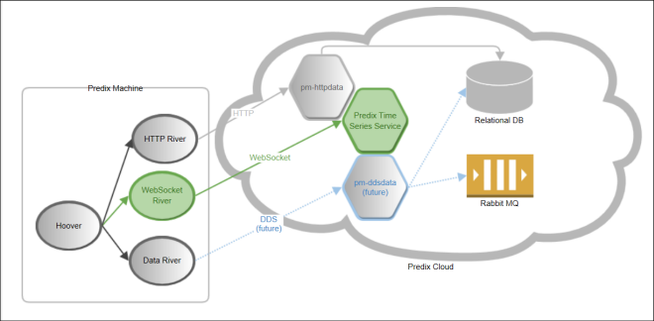

**The send operation is thread-safe, as only one active WebSocket connection exists at any given time.**

**\*\*Pushing Time Series Data**

The ingestion endpoint format is: wss://ingestion_url.

**Data Ingestion Header**

URL: wss://ingestion_url

Headers:

Authorization: Bearer <token from trusted issuer>

Predix-Zone-Id: <Predix-Zone-Id>

Origin: http://<origin-hostname>/

## Performance

| **Code** | **Message** |
| --- | --- |
| 202 | Accepted successfully |
| 400 | Bad request |
| 401 | Unauthorized |
| 413 | Request entity too large  ***Note: The payload cannot exceed 512KB.*** |
| 503 | Failed to ingest data |

**\*\*Data Query.**

The header for your query must be in this format:

URL: https://query_url/v1/datapoints

Method: POST

Headers:

Authorization: Bearer <token from trusted issuer>

Predix-Zone-Id: <Predix-Zone-Id>

***You can use both the GET and POST methods to query time series data***

Your query must specify a start field, which can be either absolute or relative. The end field is optional, and can be either absolute or relative. If you do not specify the end time, the query uses the current date and time.

* Absolute start time – Expressed as an integer timestamp value in milliseconds.
* Relative start time – Calculated relative to the current time. For example, if the start time is 15 minutes, the query returns all matching data points for the last 15 minutes. The relative start time is expressed as a string with the format <value><time-unit>-ago, where:

**\*\*Example of Relative and Absolute time**

"start": "15mi-ago", --- Relative Start Time

"end": 1427483525000, --- Absolute End Time

**Multiple queries with fewer tags in each query leads to better performance than fewer queries that include more tags.

## Data Points Limit

**Data points in the query result cannot exceed the maximum limit of **200,000**.

**The default order for query results is **ascending**, and it is ordered by timestamp.

**\*\*TimeSeries Aggregation**

## Aggregators

| **Name** | **Type** | **Parameters** | **Description** |
| --- | --- | --- | --- |
| Avg | Average | Extends the range aggregator. | Returns the average of the values. |
| Count | Count | Extends the range aggregator. | Counts the number of data points. |
| Dev | Standard Deviation | Extends the range aggregator. | Returns the standard deviation of the time series. |
| Diff | Difference | Extends the range aggregator. | Calculates the difference between successive data points. |
| Div | Divide | The divisor (double) parameter is required. This is the value by which to divide data points. | Returns each data point divided by the specified value of the divisor property. |
| Gaps | Gaps | Extends the range aggregator. | Marks gaps in data with a null data point, according to the sampling rate. |
| Interpolate | Interpolate | Extends the range aggregator. | Does linear interpolation for the chosen window. |
| least_squares | Least Squares | Extends the range aggregator. | Returns two points that represent the best fit line through the set of data points for the range. |
| Max | Maximum | Extends the range aggregator. | Inherits from the range aggregator. Returns the most recent largest value. |
| Min | Minimum | Extends the range aggregator. | Returns the most recent smallest value. |
| Percentile | Percentile | Extends the range aggregator.  percentile – Percentile to count. | Calculates a probability distribution, and returns the specified percentile for the distribution. The “percentile” value is defined as 0 < percentile <= 1 where .5 is 50% and 1 is 100%. |
| Rate | Rate | * sampling – Sets the sampling for calculating the rate. * unit – Required. Set the sampling duration as MILLISECONDS, SECONDS, MINUTES, HOURS, DAYS, or WEEKS. For example, if you set the unit to HOUR, the sampling rate is over one hour. * time_zone – Must use the long format, for example: | Returns the rate of change between a pair of data points. |
| Sampler | Sampler | Optional parameters include:   * unit – Set the sampling duration as MILLISECONDS, SECONDS, MINUTES, HOURS, DAYS, or WEEKS. For example, if you set the unit to HOUR, the sampling rate is over one hour. * time_zone – Must use the long format, for example: | Calculates the sampling rate of change for the data points. |
| Scale | Scale | factor (double) – Scaling value. | Scales each data point by a factor. |
| Sum | Sum | Extends the range aggregator. | Returns the sum of all values. |
| Trendmode | Trend Mode | * sampling – Sets the sampling for calculating the min and max within each interval. | Returns the min and max values within each interval.  ***Note: Trend Mode converts all longs to double. This causes a loss of precision for very large long values.*** |

**\*\*Create TimeSeries Instance in Window:**

cf create-service predix-timeseries <plan> <my_time_series_instance> -c "{\"trustedIssuerIds\":[\"<uaa_instance1_host/oauth/token\", \"<uaa_instance2_host/oauth/token\"]}"

**\*\*Bind Time series application to service instance:**

cf bind-service <application_name> <my_time_series_instance>

\*\***Restage** your application to ensure the environment variable changes take effect:

cf restage <application_name>

**\*\*To view the environment variables** for your application, enter the following command:

cf env <application_name>

**\*\*Authorized Grant Types**

* **authorization_code**

When you use the authorization code grant type, the client directs the resource owner to UAA, which in turn directs the resource owner back to the client with the authorization code.

* **client_credentials**

When you use the client credentials grant type, the OAuth2 endpoint in UAA accepts the client ID and client secret and provides Access Tokens.

* **password**

When you use the resource owner password credentials grant type, the OAuth2 endpoint in UAA accepts the username and password and provides Access Tokens.

* **refresh_token**

The refresh tokens are credentials used to obtain access tokens. You can choose this option to obtain refresh token from UAA. You can then use the refresh token to obtain a new access token from UAA when the current access token becomes invalid or expires, or to obtain additional access tokens with identical or narrower scope.

* **implicit**

When you use the implicit grant type, UAA directly issues an Access Token to the client without authenticating the client. This reduces the number of round trips required to obtain an access token.

**\*\*Scope:- User Permission (No App involved)**

The user permissions are for authorization grant types authorization_code, password and implicit.

**\*\*Authorities: - App Permission (No User Involved)**

The permissions are for the client_credentials authorization grant type.

**\*\*Updating the OAuth2 Client to Use Time Series**

To enable applications to access the Time Series service, your JSON Web Token (JWT) must contain the Predix zone token scopes.

For ingestion requests:

"zone-token-scopes":[

"timeseries.zones.<Predix-Zone-Id>.user",

"timeseries.zones.<Predix-Zone-Id>.ingest"

]

For time series queries:

"zone-token-scopes":[

"timeseries.zones.<Predix-Zone-Id>.user",

"timeseries.zones.<Predix-Zone-Id>.query"

]

**1.2 BlobStore**

# **Supported Operations

## Supported Operations on Stores

Operations you can perform on **stores**.

* GET Bucket (list objects)
* GET Bucket Website
* GET Bucket ACL
* List Bucket Multipart Uploads

## Supported Operations on Objects

Operations you can perform on **objects**.

* PUT Object
* GET Object
* GET Object ACL
* DELETE Object
* Abort Multipart Upload

***Blobstore supports the standard S3 V2 signature creation method. If you are on a Select plan, you must use the V2 creation method.***

***To upload large objects of greater than 100 MB, you should first split the object file into multiple parts and then perform separate uploads on each of the parts.***

# GET Bucket (List Objects)

Use the GET Bucket operation to list the objects in the specified store.

## Request Syntax

GET / HTTP/1.1

Host: <blobstore_url>

Date: <Date>

Authorization: <signatureValue>

# GET Bucket Website

The GET Bucket Website operation returns the web site configuration of a store, and requires GetBucketWebsite permission.

## Request Syntax

GET /?website HTTP/1.1

Host: <store_name>.<host>

Date: <Date>

Authorization: <signatureValue>

# GET Bucket ACL

The GET Bucket ACL operation returns the access control list for the BLOB store.

## Request Syntax

GET /?acl HTTP/1.1

Host: <blobstore_url>

Date: <Date>

Authorization: <signatureValue>

# Multipart Upload Operations

1. Split the source object into separate parts.
2. Send an [Initiate Multipart Upload](https://www.predix.io/docs/?r=271968#Qx8tNHtK) (POST) request.
3. Send an [Upload Part](https://www.predix.io/docs/?r=271967#SkvpkvXT) (PUT) request
4. After each part is uploaded, send a [Complete Multipart Upload](https://www.predix.io/docs/?r=271966#P5UQ6yao) request.

# Initiate Multipart Upload

POST /ObjectName?uploads HTTP/1.1

Host: <blobstore_url>

Date: <Date>

Authorization: <signatureValue>

# Upload Part

PUT /ObjectName?partNumber=PartNumber&uploadId=UploadId HTTP/1.1

Host: <blobstore_url>

Date: <Date>

Content-Length: <Size>

Authorization: <signatureValue>

# List Bucket Multipart Uploads

GET /ObjectName?uploadId=UploadId HTTP/1.1

Host: <blobstore_url>

Date: <Date>

Authorization: <signatureValue>

# GET Object

Use the GET Object operation to retrieve objects from the store. Authorization headers are required unless you grant READ access to an anonymous user.

GET /ObjectName HTTP/1.1

Host: <blobstore_url>

Date: <Date>

Authorization: <signatureValue>

Range: bytes=byte_range

# GET Object ACL

## Request Syntax

GET /ObjectName?acl HTTP/1.1

Host: <blobstore_url>

Date: <Date>

Authorization: <signatureValue>

Range:bytes=byte_range

# Unbinding an Application From a Blobstore Service Instance

cf unbind-service <application_name> <my_blob_store_instance>

# Abort Multipart Upload

DELETE /ObjectName?uploadId=UploadId HTTP/1.1

Host: <blobstore_url>

Date: <Date>

Authorization: <signatureValue>

# DELETE Object

DELETE /ObjectName HTTP/1.1

Host: <blobstore_url>

Date: <Date>

Content-Length: <length>

Authorization: <signatureValue>

# Deleting a Blobstore Service Instance

cf delete-service <service_instance_name>

|  |  |
| --- | --- |
| Supported Operations on Stores | GET Bucket (list objects) GET Bucket Website GET Bucket ACL List Bucket Multipart Uploads |
| Supported Operations on Objects | PUT Object GET Object Abort Multipart Upload DELETE Object GET Object ACL |
| Blobstore supports which method | S3 V2 signature creation method |
| Request Syntax for PUT Object Operation | PUT /ObjectName HTTP/1.1 Host: <blobstore_url> Date: <Date> Authorization: <signatureValue> |
| What are the required Request header for PUT Object Operation | (Required) Authorization (or Content-MD5) (Required) Date (Required) Host |
| Request Syntax for GET Object ACL Operation | GET /ObjectName?acl HTTP/1.1 Host: <blobstore_url> Date: <Date> Authorization: <signatureValue> Range:bytes=byte_range |
| What GET Bucket Website operation returns ? | web site configuration of a store, and requires  GetBucketWebsite permission. |
| What are the Blobstore samples available in Github? | Go, AWS and jclouds |
| Authentication | S3 Authentication |
| Hot to get Status of Multipart Upload |  |

**1.3 Asset Service**

**\*\*Classification of Object Hierarchy**

## Countries Object Example

The custom Countries modeling object has two children: USA and Japan.

**Figure 3. Countries Object** 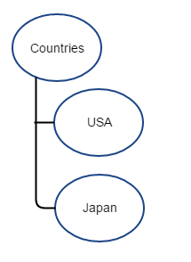

[

  {

    "uri": "/countries",

    "name": "Countries",

    "obsolete": false,

    "attributes": {

    }

  },

  {

    "uri": "/countries/USA",

    "name": "USA",

    "parent": "/countries",

    "obsolete": false,

    "attributes": {

    }

  },

  {

    "uri": "/countries/Japan",

    "name": "Japan",

    "parent": "/countries",

    "obsolete": false,

    "attributes": {

    }

  }

]

** **x-audit-metadata**: used to query the audit history

** **Snapshot**: it is a complete version of asset data that included both old and new value of the changed data.

**\*\* Changes:** It included only the field the changed with old and new value.

**\*\*Asset Service Request Methods:**

**GET:** Retrieves resources. Use GET /assets to return all domain objects.

**POST:** Creates or updates a set of resources. A POST request cannot exceed 50 MB. You can POST to a collection, but not to a specific resource

**PUT:** Creates or updates a single resource. You can use this method for an individual resource, but not for a collection.

**PATCH:** Update values of a resource property. You can add, remove, modify, and replace values of a resource record. You can use this method for an individual resource, but not for a collection.

**DELETE:** Removes or deletes a resource. You can use this method for an individual resource, but not for a collection.

**\*\*Asset Service Request Parameters:**

**Fields:** Retrieves selected fields of a large object or a collection of large objects.

**Filter**: Use Graph Expression Language (GEL) in the filter clause of a GET request to filter the data that appears in results.

**PageSize**: Defines the number of entities to be returned per page (default is 100). Maximum pageSize is 1000.

**\*\*Filters are not allowed in POST, PUT, PATCH, or DELETE requests.**

**\*\*What is the Unique Identifier? URI**

## GEL Symbols and Operators

## **GEL Symbols and Operators

| **Symbol** | **Operator** | **Interpretation** |
| --- | --- | --- |
| **()** |  | Use parentheses to override the default left-to-right order of operations. Evaluation then takes place from left to right within the parentheses first. The the single result is then used as a single term for evaluation outside the parentheses. |
| **:** | AND | Read the colon character ":" as AND. The ampersand "&" is a reserved character and has special meaning in URLs.  See [EQUALS (=) combined with AND (:)](https://www.predix.io/docs/?r=372989#ZXrDMgLB). |
| **|** | OR | Read the pipe "|"as OR.  See [EQUALS (=) combined with OR (|)](https://www.predix.io/docs/?r=372988#ZXrDMgLB). |
| **..** | RANGE | Read two periods (..) as a range between two numbers, two dates, or two strings.  See [RANGE (..) Operator Requests](https://www.predix.io/docs/?r=372987#xfix4vDu) |

**\*\*GEL Queries**

Example JSON: {uri: /assets/1, a.b : c}

The query for "c" would look like this: filter=a\.b=c

Example JSON: {uri : /assets/1, a:{b:c}} To query for "c" in this case, do not escape the dot. filter=a.b=c

**\*\*RELATE Operators**

**“>”** (FORWARD-RELATE)

Retrieves all engines linked to locomotives of type Diesel-electric.

*<asset-app-url>*/engines?filter=type=Diesel-electric>engine

**“>[token]”** (FORWARD-RELATE with transitive closure)

Read the letter "t" followed by a number enclosed in square brackets [t*n*] as a transitive closure token. For example, the following query retrieves all parent assets of piston asset, moving up five levels in the asset hierarchy:

/asset?filter=name=piston>parent[t5]

**“<”** (BACKWARD-RELATE)

<asset-app-url>/locomotive?filter=(name=General Electric Transportation)<manufacturer

-- above query will retrieves all locomotives with a given manufacturer.

**“<[token]”** (BACKWARD-RELATE with transitive closure)

/asset?filter=name=GE-Aircraft<parent[t5]

Error Code = PA_ENTITY_KEY_EXCEEDS_CHAR_LIMIT

message": "Entity keys may not contain more than 65000 characters"

suggestion": "Please ensure all entity keys contain no more than 65000 characters".

**\*\*Range Operator:**

**Date**: If we compare the date which is not in ISO format it will compared as string

Wild card Search with regular operation:

<asset-app-url>/(locomotive?filter=type=/*.ese*./)

**\*\*Attribute keys and attribute values are limited to 65,000 characters.**

**\*\*Unbind Asset Service from an application name “myAppName”**

cf unbind-service <myAppName> <my_asset_instance>

**\*\*Delete Asset Service**

cf delete-service predix-asset <my_asset_instance>

**\*\*Audit History:**

Audit History is disabled by default. Users must make a REST API call to the endpoint/system/configs on the Predix Asset service to enable and disable the service explicitly.

To enable Audit History, include this JSON array in the body:

[

{

"enableAudit" : true

}

]

To disable Audit History, include this JSON array in the body:

[

{

"enableAudit" : false

}

]

**\*\*Equal (=) and colon (:)** are the only allowable operators. The Asset Service validates request parameters and rejects any other GEL operator with an appropriate error code.

| Table 2. Time Range Filters for Audit History Queries | |
| --- | --- |
| **Type of Query** | **Notes** |
| Queries based on audit timestamps | Use before and after |
| Queries based on event timestamps | Use eBefore and eAfter. |

***Note: The value for before and eBefore operators can only be a date in the ISO8601 format. Example: 2016-03-25T06:10:36.661+05:30***

* This example shows a query for just one timestamp and user ID:

/system/audit?filter=before=ISO 8601 : userId=12345

* This example shows a query based on specific metadata:

/system/audit?filter=reason="":userId= 12345

* This example shows a query based on a specific action:

/system/audit?filter=action=CREATE

** System Generated Metadata Attributes

**Attributes Description**

Date & Time indicate date and time the request was submitted against data

Action Indicates the operation used in the request

Old & New Values Indicate the value of the asset or domain object before the object and new value after change.

1. **EDGE SOFTWARE AND SERVICES**

**2.1 Predix Machine**

Predix Machine uses a Java software stack that is built in the Open Services Gateway initiative (OSGi) framework and is capable of running on Windows and UNIX-like operating systems, such as Linux or MacOSX. The OSGi framework provides a modular architecture, which allows developers to tailor the platform’s implementation to the needs of the use case, leveraging and deploying only the services that are necessary.

## New Features

**Cloud Gateway**

Cloud Gateway manages packages and notifications sent from the cloud.

**Device Detail Service**

The Device Detail service retrieves dynamic information for devices by interacting with a set of defined APIs and forwarding the retrieved information to the cloud.

**Certificate Enrollment in Technician Console**

You can use the Technician Console to enroll certificates for Predix cloud enrollment.

**Silent Installation of Windows Service**

You can perform a silent installation of the Predix Machine Windows Service.

**Installation and Command Logging**

Installation and command statuses are written to their respective files.

**OpenVPN**

Predix Machine provides OpenVPN, with the required certificate, to connect to the Predix Connectivity VPN server.

**Data Bus**

Facilitates communications between Dockerized applications within an edge device.

**Data Bus Machine Adapter**

Uses the existing Machine Gateway Adapter to get data from the Data Bus.

**Data Bus River**

Allows you to transmit data from Predix Machine to other applications on the same device using the Data Bus River.

**Data Communication Java and C++ APIs**

Allows C++ and Java applications running in application containers to communicate with the Data Bus.

**Predix Machine edge SDK**

Allows you to write applications in various languages to communicate to Predix Machine through the Data Bus.

The following feature has been added to improve communication between the Predix Machine runtime container and those applications that are outside of the container:

**Little Proxy**

Allows trusted applications that run outside of the Predix Machine container to communicate with the cloud by proxying requests.

The following feature has been added to support 32-bit devices:

**Watchdog Script Process**

The mBSA Watchdog is no longer used in Predix Machine. It has been replaced by a watchdog script process that allows for support of any device, including ARM7 devices, which did not support mBSA.

# **Upgrade Return Codes

Find out what Predix Machine upgrade return codes mean.

Return code 0 indicates that your Predix Machine upgrade was successful.

Return codes between 20-49 indicate a problem with the package, or with Yeti.

Return codes greater than 50 indicate a problem with the install script or procedure.

# **Working with Slow Machines

When a config is pushed to a slow machine the yeti process often times out before the new config can be installed and rolls back the installation. The yeti.cfg file allows you to configure the timeout value allowing configs to install on slow machines. **The default is 600 seconds in 10 second increments.**

**\*\*WebSocketRiver**

supports int, long, flot, double data type only. Boolean data converted into 1 or 0.

# **HTTP River Service

## Limitations

The maximum size for the data store in the database is 4GB.

# **Command Framework

### Command Output

Output for a command should only be returned in one of the two ways listed below. If both ways are implemented for a command, only the output in the CommandStatus object (first way) will be shown in the EdgeManager UI.

1. Output is sent through the CommandStatus object in the Output field.

***Note: This is limited to String output of size < 1KB.***

1. Output is uploaded through the provided URL.

## Command Status Enum

## Command Status Enum

The following table describes the enum values and descriptions for settings in theCommandStatus object.

| **Enum** | **Description** |
| --- | --- |
| ACKNOWLEDGED | The task is acknowledged by the device. |
| SUCCESS | The task completed successfully.. |
| DELIVERED | The task has been delivered to an application/service to handle. |
| FAILURE | The task failed to complete. |
| NOTSUPPORTED | The task cannot be processed. |

|  |  |
| --- | --- |
| **Property** | **Description** |
| com.ge.dspmicro.predixcloud.identity.oauth.authorize.url | The URL of an OAuth2 authorization endpoint. This is the UAA URL for the technician to log into the cloud. |
| com.ge.dspmicro.predixcloud.identity.uaa.enroll.url | The Predix cloud enrollment URL. This URL is called once when creating credentials during enrollment. |
| com.ge.dspmicro.predixcloud.identity.uaa.token.url | The Predix cloud User Account and Authentication (UAA) endpoint for getting a token using client_credentials grant type. |
| com.ge.dspmicro.predixcloud.identity.uaa.clientid | The client ID assigned to the device. If this property has a value, this device is enrolled . If it is blank, the device is not enrolled. |
| com.ge.dspmicro.predixcloud.identity.uaa.clientsecret | Client secret. This value is automatically encrypted when the service is started. |
| com.ge.dspmicro.predixcloud.identity.deviceid | Predix device identity.  Must contain only lower case letters (a-z), numbers (0-9), and : - _. Must begin with a letter or number. |
| com.ge.dspmicro.predixcloud.identity.asdid |  |
| com.ge.dspmicro.predixcloud.identity.tenantid |  |
| com.ge.dspmicro.predixcloud.identity.mac | [Required if using JWT AuthMode] Predix device MAC address used to pin certificate to device. Acceptable formats are 6 bytes of case insensitive hex with each byte separated by ':','-' or none example: xx:xx:xx:xx:xx:xx or xx-xx-xx-xx-xx-xx or XxXxXxXxXxXx |
| com.ge.dspmicro.predixcloud.identity.cloud.upload.url | Predix cloud upload URL - This is used for uploading configuration command from the device.  The device id will be appended automatically to the end of the URL if not set.  When the device is enrolled this value will be set automatically. |
| com.ge.dspmicro.predixcloud.identity.yeti.signature.url | Predix cloud Yeti signature URL - The cloud service for validating install packages.  When the device is enrolled this value will be set automatically. |

PredixMachineContainer path: /etc/com.ge.dspmicro.predixcloud.identity.cfg

com.ge.dspmicro.predixcloud.identity.uaa.token.url= <UAA issuerid> (paste from cf env output)

com.ge.dspmicro.predixcloud.identity.uaa.clientid= sample-clientid

com.ge.dspmicro.predixcloud.identity.uaa.clientsecret=sample-clientid

The configuration properties for the Modbus bundle can be found in

etc/com.ge.dspmicro.machineadapter.modbus-0.xml

/etc/com.ge.dspmicro.hoover.spillway-o.cfg file

/etc/com.ge.dspmicro.httpriver.send-0.cfg

Open Platform Communications Unified Architecture

**2.2 EdgeManager**

Predix EdgeManager provides a single point of entry for deploying and monitoring remote devices.

EdgeManager allows you to administer your applications and configuration files at both a device and a fleet level, helping you keep your device software current.

## **Main functions**

EdgeManager provides the following functionality,

**User management**

* Add and delete users
* Reset user passwords
* Assign roles to users
* Change passwords for signed-in users

**Note**: You can assign multiple roles to a user.

**Note**: You cannot make changes to your own user role when you are logged in with that role.

**Device management**

* View device details, such as resource usage, power supply information, device health, and connectivity
* Allow multi-group selection
* Access detailed execution logs
* Create, save, and edit custom filters
* Filter the device list by name, attributes, operator, and value
* Create, update, and delete device groups
* Add and delete devices
* Get device summaries
* Assign technicians to devices
* Open a secure SSH tunnel to remote devices
* Create and execute custom commands
* Execute commands to multiple devices and get output or error reasons

**Application/configuration management**

* View information about software and configuration deployments
* Upload configurations to repositories
* Schedule app/config deployments to one or multiple devices
* Assure certificate-based device authentication
* Allow auto-enrollment for devices
* Provide multi-tenancy support
* Support multiple tenants with single app deployment

| **Role** | **Description** | **Access to** |
| --- | --- | --- |
| Technician | This role is assigned by the EdgeManager administrator. Technicians can enroll devices in the cloud using the Predix Machine Technician Console. | * Control Panel * Settings |
| Operator | This role has the same access to the functionality in EdgeManager as the administrator, with the exception of user management. | * Control Panel * Device Manager * Device Manager > Groups * Device Manager > Device Models * Repository * Commands * Connectivity * Settings |
| Administrator | The administrator has access to all EdgeManager functionality. | * Control Panel * Device Manager * Device Manager > Groups * Device Manager > Device Models * Repository * Commands * Connectivity * User Manager * Settings |

## EdgeManager Workflow

The following diagram shows the high level workflow for EdgeManager.

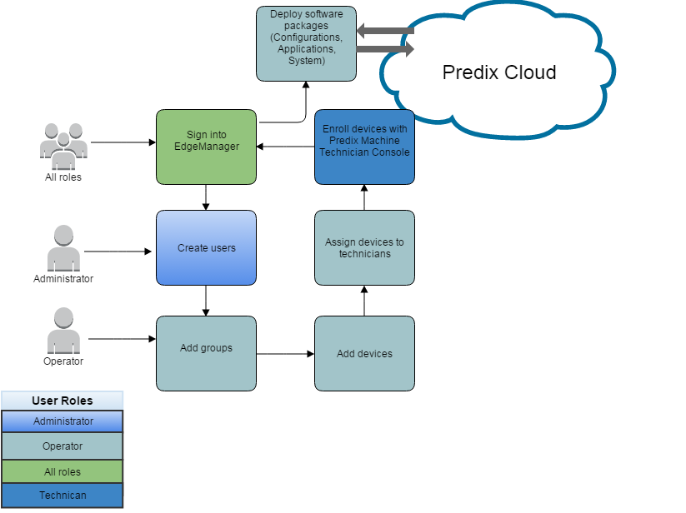

**Related concepts**

**You see the EdgeManager Dashboard, and the Control Panel pane on the left, where you can access Device Manager, Repository, Commands, Connectivity, User Manager, and Settings.

**The Dashboard shows information about enrolled devices, such as unassigned devices and unreachable devices. You can click on a device to go to the device details page

**Note**: If you are a technician, you do not see the dashboard. The UAA URL and Enrollment URL are displayed for your convenience.

***Note: EdgeManager supports most shell commands, but does not support the following:***

Interactive shell editor commands, such as Vi, emacs, and nano.

Commands with non-printable characters, such as ctrl+c, ctrl+d, and so on.

Commands Overview

Use the Commands page to:

* View all system-defined and custom commands.
* View the details of each command.
* Add and delete custom commands.

The Commands page includes the following system-defined default commands, which cannot be edited or deleted:

* Application Container: **Delete** – Deletes a container from the device.
* Application Container: **Start** – Starts a running container on the device.
* Application Container: **Stop** – Stops a running container on the device.
* HTTP Tunnel: **Disable** – Disables the HTTP tunnel to prevent data transfer from the device to the cloud.
* HTTP Tunnel: **Enable** – Enables data transfer from the device to the cloud.
* Predix Machine: **Get Application Containers** – Returns a list of Docker containers.
* Predix Machine: **Get Available Logs** – Returns a list of available logs on the machine.
* Predix Machine**: Get IP Address** – Posts the network interface information with all available device IP addresses to the provided URL endpoint.
* Predix Machine: **Get Log** – Retrieves the Predix Machine log from the device.
* Predix Machine: **Refresh** – Restarts the Predix Machine OSGi container process. This command is not permitted if the watchdog is not running.
* Predix Machine: **Restart** – Restarts the Predix Machine OSGi container.
* Predix Machine: **Set Polling Interval** – Sets the polling interval for synchronizing the device data with the database.
* Predix Machine: **Upload Configurations** – Uploads a configuration to the device.
* Technician Console: **Disable** – Disables the Predix Machine Technician Console on the device.
* Technician Console: **Enable** – Enables the Predix Machine Technician Console on the device.

SIM Card Life Cycle

The following diagram displays the different states of the SIM card life cycle.

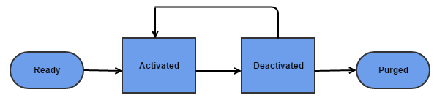

* **Ready**
  + Unless otherwise specified when ordering, Ready is the default state for new SIM cards.
  + When a minimum amount of data is passed on the SIM card, Ready transitions to Activated.
  + Ready is a system state, and is not user-configurable.
* **Activated**
  + Until the SIM card is in the Activated state, there is no billing.
  + The Activated state allows the SIM card to pass data (subject to the associated rate plan).
  + You can customize this state.
* **Deactivated**
  + In the Deactivated state, the SIM card is no longer provisioned to pass data.
  + You can customize this state.
* **Purged**
  + Once the SIM card is in the Purged state, the SIM card cannot be reused.
  + The Purged state is configurable by administrators only.
* **Suspended**
  + When the SIM card exceeds the data usage of its associated plan, it is suspended.
* **Not Available**
  + The Not Available state indicates an error with communication between the service provider and the SIM card.
  + If the Not Available state persists, contact support.

**\*\*Webhooks** – Create webhooks so that when device status changes, a notification is sent.

**\*\*Creating Webhooks**

Create up to 10 webhooks for receiving information about changes in device status, for example, when a device changes status from reachable to unreachable and vice versa.

1. In EdgeManager go to Settings > Webhooks .
2. Click + and add a new payload URL for the server endpoint that will receive the webhook payload.

You can add up to 10 webhooks.

The following payload is sent to the webhooks you added.

{

"eventType": string,

"deviceid": string,

"created": timestamp,

"data": {

"status": string

}

1. **SECURITY:**

**3.1 Tanent Management**

Tenant Management service provides REST APIs for storing, updating, retrieving, and deleting client credentials.

In a multi-tenant environment, a tenant is an application or a group of users that share resources such as data, configuration, and user management. The tenants are logically isolated but physically integrated.

**Tiered Pricing per 1,000 instances**

|  |  |  |  |  |  |
| --- | --- | --- | --- | --- | --- |
| **Feature** | **Tier 1** | **Tier 2** | **Tier 3** | **Tier 4** | **Tier 5** |
| **Instances** | < 10K | 10 - 100K | 100 - 200K | 200 - 350K | >350K |
|  | $0.61 | $0.58 | $0.55 | $0.53 | $0.50 |

***Note: The service instances are deleted only if they were created using the Tenant Management service for that tenant.***

**\*\*<API_Endpoint>:**

Predix US-West

<https://api.system.aws-usw02-pr.ice.predix.io>

Predix US-East

<https://api.system.asv-pr.ice.predix.io>

Predix Japan

<https://api.system.aws-jp01-pr.ice.predix.io>

Predix UK

https://api.system.dc-uk01-pr.ice.predix.io

**\*\*Authorities or Scopes Required for Tenant Management Service**

To enable applications to access the Tenant Management service, your JSON Web Token (JWT) must contain the following scopes:

* tms.tenant.read

This is required for using the Tenant management service read APIs.

* tms.tenant.write

This is required for using the Tenant Management service write APIs.

* predix-tms.zones.<tms_instance_guid>.user

This value is generated in the VCAP_SERVICES environment variable as oauth-scope when you bind your application to your Tenant Management service instance.

* tms.tenant.credentials.admin

This is required for using the Tenant Management service API for storing, updating, and deleting client credentials.

* tms.tenant.credentials.read

This is required for authentication when retrieving client credentials.

# Creating a Tenant

HTTP POST

/tenant

# **Retrieving Service Instance Details

1. Use the following REST API to retrieve the details of all service instances for a tenant:

HTTP GET

/v1/tenant/{tenantName}

1. Use the following REST API to retrieve details of a specific service instance for a specific tenant:

HTTP GET

/v1/tenant/{tenantName}/service/{serviceName}

***If you required the credential of a specific service instance, use the following REST API:***

***HTTP GET***

***/v1/tenant/{tenantName}/service/{serviceName}/credentials***

# **Updating a Tenant

HTTP PUT

/v1/tenant

# **Updating Services Provisioned Using Tenant Management Service

You can update services that you provisioned using Tenant Management service.

Use the following REST API to update a service:

HTTP PUT

/v1/tenant/{tenantName}/service/{instanceName}

# **Deleting a Tenant

You can use the Tenant Management service REST API to delete a tenant. When you delete a tenant, all service instances associated with that tenant are also deleted if they are not being used by another tenant.

Use the following REST API to delete a specific tenant:

HTTP DELETE

/v1/tenant/{tenantName}

# **Storing Client Credential

POST

https://<tenant-sub-domain>.<tms.services>/client-credentials

# **Updating Client Credential

HTTP PUT

https://<tenant-sub-domain>.<tms.services>/client-credentials

# **Retrieving Client Credential

GET https://<tenant-sub-domain>.<tms.services>/client-credentials

# **Deleting Client Credential

To delete client credentials for a given authorized client

DELETE https://<tenant-sub-domain>.<tms.services>/client-credentials/client-ids/<client-id>/authorized-clients/<authorized-client-id>

To delete credentials for an "all" authorized client

DELETE https://<tenant-sub-domain>.<tms.services>/client-credentials/client-ids/<client-id>

# User Account and Authentication

UAA is a multi-tenant identity management service used in Cloud Foundry that's also available as a standalone OAuth2.0 server. Its primary role is as an OAuth2.0 provider to issue tokens to client apps to use when they act on behalf of Cloud Foundry users. UAA can act as an SSO service using SAML. It has endpoints for managing user accounts and for registering OAuth2.0 clients, as well as various other management functions.

**Pricing Options**

**Tiered Pricing per 1,000 Tokens**

|  |  |  |  |  |
| --- | --- | --- | --- | --- |
| **Feature** | **Tier 1** | **Tier 2** | **Tier 3** | **Tier 4** |
| **Tokens issued** | < 100K | 101 - 1,000K | 1,001 - 3,000K | >3,000K |
|  | $2.00 | $1.4 | $0.98 | $0.1 |

***Note: The maximum number of UAA instances that you can create in your space is 10. As a best practice, use the same UAA instance for your services***

The following diagram shows how UAA integrated with federated identity management.

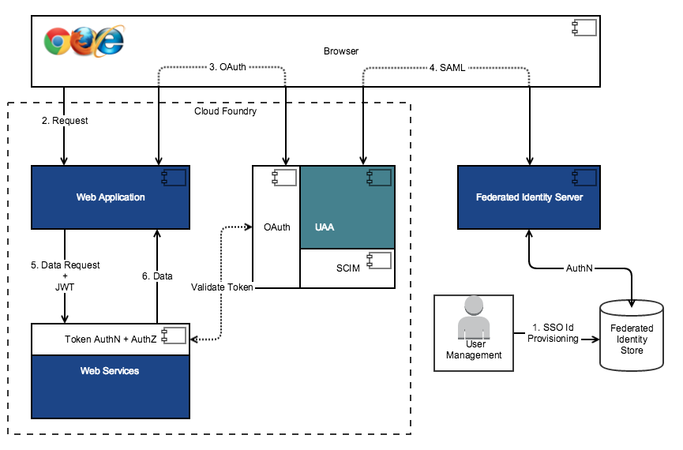

**Create a UAA Instance

cf create-service predix-uaa <plan> <my_uaa_instance> -c '{"adminClientSecret":"<my_secret>","subdomain":"<my_subdomain>"}'

Binding an application to UAA Instance

cf bind-service <your_app_name> <uaa_instance_name>

Un Bind UAA Service Instance

cf unbind-service <your_app_name> <uaa_instance_name>

Delete UAA Service Instance

cf delete-service predix-uaa <uaa_instance_name>

**\*\*Authorized Grant Types:**

* 1. authorization_code
  2. client_credentials
  3. password
  4. refresh_token
  5. implicit

**\*\*Scopes:**

1. authorization_code
2. password
3. implicit..

**\*\*Creating Oauth2 Client:**

Specify your UAA instance as the intended target.

uaac target <uaa_instance_url>

Log in using the administrative client.

uaac token client get admin

Use the following command to create the OAuth2 client:

uaac client add [client_name]

--authorities "uaa.resource"

--scope "openid"

--autoapprove "openid"

--authorized_grant_types [authorization_code|implicit|password|client_credentials|refresh_token]

--redirect_uri [redirect_uri_1, redirect_uri_2, ...]

**VVI: The following table lists the scopes and authorities specific to each platform service that you must add to your OAuth2 client.**

| **Service Name** | **Authorities/Scopes** |
| --- | --- |
| **Access Control** | * acs.policies.read * acs.policies.write * acs.attributes.read * acs.attributes.write * predix-acs.zones.<acs_instance_guid>.user   This value is added by default if you use UAA Dashboard. It is also generated in the VCAP_SERVICES environment variable as oauth-scope when you bind your application to your ACS service instance. |
| **Tenant Management** | * tms.tenant.read * tms.tenant.write * predix-tms.zones.<tms_instance_guid>.user (added by default) |
| **Analytics Catalog** | analytics.zones.<service_instance_guid>.user (added by default) |
| **Analytics Runtime** | analytics.zones.<service_instance_guid>.user (added by default) |
| **Asset** | predix-asset.zones.<service_instance_guid>.user (added by default) |
| **Time Series** | * Data ingestion   + timeseries.zones.<Predix-Zone-Id>.user (added by default)   + timeseries.zones.<Predix-Zone-Id>.ingest * Data queries   + timeseries.zones.<Predix-Zone-Id>.user (added by default)   + timeseries.zones.<Predix-Zone-Id>.query |
| **View** | * views.zones.<view_instanceId>.user (added by default) * views.admin.user * views.power.user |

***use browser plugin tools such as SAML Tracer for Firefox to validate SAML flow.***

**\*\*Changing the UAA Client Secret:**

Specify your UAA instance as the intended target.

uaac target <uaa_instance_url>

Log in using the administrative client.

uaac token client get admin

Use the following command to change the OAuth2 client Secret:

uaac secret change

**\*\*Create User in UAA Instance:**

1. Create a new user.

uaac user add <my-user> --emails <my_user>-user@ge.com --password <my_password>

1. Create the groups in your UAA instance.

uaac group add scim.read

uaac group add scim.write

1. Add the new user to the required groups.

uaac member add zones.<my_uaa_instance>.admin <my-user>

uaac member add scim.read <my-user>

uaac member add scim.write <my-user>

uaac member add clients.write <my-user>

uaac member add clients.read <my-user>

uaac member add clients.admin <my-user>

uaac member add clients.secret <my-user>

1. Verify that the user is created with the correct scope.

uaac token owner get <my-oauth-client> <my-user>

uaac token decode

**\*\*** UAA supports SAML protocol for communicating with IdPs or SPs.

IdPs: Identity Providers

SPs: Service Provider

## ** Configuring UAA as Service Provider for External Identity Provider

## **Configuring UAA as Service Provider for External Identity Provider

Create the SAML Identity Provider for the specified UAA instance

./create-saml-idp.sh -n <my-idp-name> -m <idp-metadata>.xml -a -c <mapping-config-file> -g <groups-config-file>

Validate that the identity provider

uaac curl /identity-providers

Create a client with the specified identity provider (IdP)

./create-client-for-idp.sh -c <client_id> -s <client-secret> -p <my-sso-idp> -r <redirect_uri>

Validate that your client

uaac client get <client_id>

# Access Control Services

Use the Access Control service to provide a more powerful authorization framework than basic [User Account and Authorization (UAA) service](https://www.predix.io/services/service.html?id=1172). The Access Control service provides app-specific policies without adding overhead to a UAA server that may become the entry point for several apps over time.

In addition, you can build:

* Access Control policies that can change over the lifetime of a single JSON Web Token issued for the user.
* Attribute-based Access Control by assigning attributes to both users and resources within your system.
* Access Control policies based on many complex conditions.

**Pricing Options**

**Tiered Pricing per 1,000 evaluations**

|  |  |  |  |  |
| --- | --- | --- | --- | --- |
| **Feature** | **Tier 1** | **Tier 2** | **Tier 3** | **Tier 4** |
| **Evaluations** | < 100K | 101 - 1,000K | 1,001 - 3,000K | > 3,000K |
|  | $2.0 | $1.4 | $0.98 | $0.1 |

***Note: The maximum number of ACS instances that you can create in your space is 200.***

# ACS Deployment Architecture

The following diagram shows how ACS services are deployed in cloud foundry.

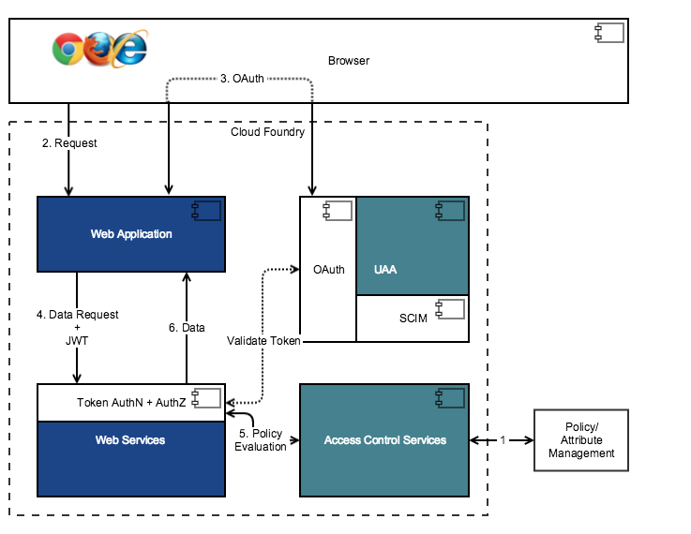

The following diagram shows the Access Control Services architecture.

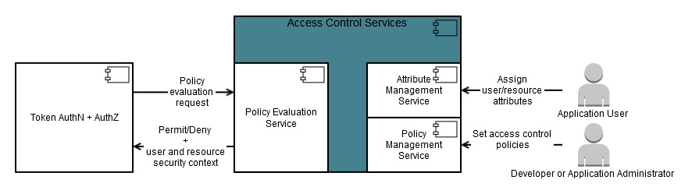

* **Policy Management service** -> CRUD operations for application policies.
* **Attribute Management service** -> CRUD operations for user and resource attributes.
* **Policy Evaluation service** -> processes policy evaluation (such as access control) requests for an OAuth client.

To use the Policy Management service, the user/client must authenticate using a JWT bearer token that includes the predix-acs.zones.<acs_instance_guid>.user scope along with acs.policies.read scope for reading the policies or the acs.policies.write scope for writing the policies.

**ACS Policies: name, target, effect, condition**

You must specify the Predix-Zone-Id header when you use the REST APIs.

**\*\*Create an ACS Instance:**

cf create-service predix-acs <plan> <my_acs_instance> -c '{"trustedIssuerIds":["<uaa_instance1_issuerId>", "<uaa_instance2_issuerID>"]}'

**\*\*Bind your application with ACS Instance:**

cf bind-service <your_app_name> <acs_instance_name>

**Use the /policy-set/{policySetId} REST APIs (PUT, GET, and DELETE) to create a suite of policies

** ACS Element “**effect**” can be either DENY or PERMIT.

** To use the **Attribute Management service**, the user/client must authenticate using a JSON Web Token (JWT) that includes the

* + 1. acs.attributes.read,
    2. acs.attributes.write
    3. predix-acs.zones.<acs_instance_guid>.user scope

1. Use the following REST API to create attributes for the resources:

HTTP Post

v1/resource

1. Use the following REST API to create attributes for the subjects:

HTTP Post

v1/subject

**\*\*** Include the **isAcsAuthorized**() expression in the access attribute on http element for resources that need to be protected with ACS.

# **Configuring ACS Details

ACS spring security extensions require ACS instance details to delegate resource authorization to ACS.

You can use the ACS spring security extensions in one of the following two ways:

* Use the default implementation,

com.ge.predix.acs.spring.security.config.AcsClientConfigurationProvider.

The default implementation relies on the UAA and ACS services information to be available in your application property file.

* Override the default implementation by creating your own implementation of the

com.ge.predix.acs.spring.security.config.AcsClientConfigurationProvider interface.

You can use this option if your application requires multiple OAuth2 clients accessing ACS.

**\*\*Configure Custom Provider**

If you need to override the default implementation, you can create your own implementation as follows:

* Implement the

com.ge.predix.acs.spring.security.config.AcsClientConfigurationProvider interface.

* Annotate the implementation with @Primary and @Component. This ensures that your implementation is used while calling ACS.

**\*\*Providing Additional Subject Attributes for Policy Evaluation**

To provide additional attributes:

* Implement the

com.ge.predix.acs.spring.security.extensions.policy.evaluation.AcsPolicyEvaluationRequestCustomizer interface.

* Annotate the implementation with @Primary and @Component to ensure it is used when calling ACS.

1. **ANALYTICS SERVICES:**

**4.1 Analytics Catalog**

**Pricing Options**

**Fixed Plan**

|  |  |  |  |  |
| --- | --- | --- | --- | --- |
| **Feature** | **Unit** | **Bronze** | **Silver** | **Gold** |
| **Storage** | GB | 5 | 10 | 15 |
| **Validation executions** |  | 3,000 | 15,000 | 30,000 |
|  |  | **$60** | **$200** | **$352** |

**Free Plan**

You can try Analytics Catalog right now. Just subscribe to the Free Plan below, and get 1 GB storage and 10 validation executions - all at no cost and with no time limit. Need more? Upgrade to your choice of paid plans at any time.

The Analytics Catalog service offers a repository for hosting analytics and exposing them as a service in the Predix platform.

The Analytics Catalog REST API provides mechanisms for managing entries in the catalog (create,retrieve, update, delete), for deploying analytics to the Predix platform, and for validating deployed analytics.

To enable applications to access the Analytics Catalog service, your JSON Web Token (JWT) must contain the following scope:

analytics.zones.<catalog_service_instance_guid>.user

**Client Credential Type**

For a client credentials grant type, the body must contain the following:

grant_type=client_credentials.

**Password Grant Type**

For a password grant type, the body must contain the following:

* grant_type=password
* username=<my_user_name>
* password=<my_password>

Creating a Analytics catalog

cf create-service predix-analytics-catalog <plan> <my_service_instance> -c '{"trustedIssuerIds":["<uaa_instance1_issuerId>", "<uaa_instance2_issuerID>"]}'

Binding service instance with your app

cf bind-service <app_name> <service_instance_name>

Verify the binding:

cf env <app_name>

# **Adding an Analytic to the Analytics Catalog

* 1. Create Analytics

POST <*catalog_uri*>/api/v1/catalog/analytics

* 1. Attach artifacts

POST <*catalog_uri*>/api/v1/catalog/artifacts

* 1. Validate Analytics

POST <*catalog_uri*>/api/v1/catalog/analytics/{*analyticId*}/validation

* 1. Poll for Validation Status

GET <*catalog_uri*>/api/v1/catalog/analytics/{*analyticId*}/validation/{*validationRequestId*}

* 1. Retrieve the Analytic Validation status

Use the validationRequestId from the previous step to check the status of the deployment and validation. The status can be QUEUED, PROCESSING, or COMPLETED. If the status is COMPLETED, the response includes the analytic execution result.

* GET  <*catalog_uri*>/api/v1/catalog/analytics/{id}/validation/{validationRequestId}

***Note: The maximum file size for upload is 250MB. The maximum expanded analytic file size (including directories and files) is 500MB.***

# **Updating an Analytic's Executable Artifact

PUT <*catalog_uri*>/api/v1/catalog/artifacts/{id}

# **Deploying a Production Analytic to Cloud Foundry

Deploy the analytic by issuing the following REST API request.

The request to deploy an analytic is an asynchronous request. The response contains a requestId that can be later used to retrieve the deployment status.

POST <*catalog_uri*>/api/v1/catalog/analytics/{id}/deployment

The following sample request configures and initiates a deployment.

{

"memory":<Memory size in MB>,

"diskQuota":<Disk space in MB>,

"instances":<Number of instances>

}

For example

{

"memory":1024,

"diskQuota":512,

"instances":2

}

Be aware of the following:

* Default values are assumed if memory, disk quota, and instance are not given or if amount given is smaller than the default value.
* Default values are: memory, 512 MB; disk quota, 1024 MB for Java and Python, 2048 MB for Matlab;instance is 1.
* If the given memory and disk quota values are greater than what the Predix platform supports, the analytic deployment will fail.
* If the given memory value exceeds 7500MB, the analytic deployment will fail.
* If the given number of instances exceeds two, the analytic deployment will fail.

# **Retrieving Recent Analytic Logs

GET <*catalog_uri*>/api/v1/catalog/analytics/{id}/logs

# **Deleting an Analytic From the Catalog

DELETE <*catalog_uri*>/api/v1/catalog/analytics/{id}

# **Adding Taxonomy Locations

POST <*catalog_uri*>/api/v1/catalog/taxonomy

**4.2 Analytics Runtime**

**Pricing Options**

**Fixed Plan**

|  |  |  |  |  |
| --- | --- | --- | --- | --- |
| **Feature** | **Unit** | **Bronze** | **Silver** | **Gold** |
| **Production analytic** |  | 25 | 250 | 500 |
| **Total Data I/O per month** | GB | 0.1 | 1 | 2 |
| **Memory per analytic execution** | GB | 0.5 | 1.5 | 2.5 |
|  |  | $1,000 | $5,700 | $10,530 |

**Free Plan**

You can try Analytics Runtime right now. Just subscribe to the Free Plan below and get 5 production analytics and 0.1 GB memory per analytic execution - all at no cost and with no time limit.

The orchestration is specified using the Business Process Model Notation (BPMN) XML, with references to analytics in the Catalog and third-party analytics.

**Create Runtime Analytics**

cf create-service predix-analytics-runtime <plan> <my_service_instance> -c '{"trustedIssuerIds":["<uaa_instance_issuerId>","<uaa_instance2_issuerId>"]}’

Binding an application to Runtime Analytics service:

cf bind-service <app_name> <service_instance_name>

**Client Credential Type**

For a client credentials grant type, the body must contain the following: grant_type=client_credentials.

**Password Grant Type**

For a password grant type, the body must contain the following:

* grant_type=password
* username=<my_user_name>
* password=<my_password>

The response will contain the following structure.

{

"access_token":<generated_access_token>,

"token_type":"bearer",

"expires_in":3600

}

# **Running an Orchestration with One Analytic

# We need below three things to execute Orchestration

* analytic catalog entry ID
* analytic name
* analytic version
  1. Update above three values in BPMN workflow (OrchestrationWithOneAnalytic.xml) in service Task section.

<serviceTask completionQuantity="1"

id="sid-10001"

isForCompensation="false"

name="<Analytic Catalog Entry Id>::<Analytic Name>::<Analytic Version>"

startQuantity="1"

activiti:delegateExpression="${javaDelegate}"

xmlns:activiti="http://activiti.org/bpmn">

<incoming>sid-flow1</incoming>

<outgoing>sid-flow2</outgoing>

</serviceTask>

2.Prepare the input for the demo analytic and save as a file.

[

{

"analyticStepId": "sid-10001",

"data": "{ \"number1\" : 5, \"number2\" : 24 }"

}

]

3.Send an orchestration execution request by issuing the following REST API request.

POST <*execution_uri*>/api/v2/execution/testrun

# **Configuring an OAuth2 Client for Scheduler

Scope:

analytics.zones.<analytics-catalog-service-instance-id>.user

analytics.zones.<analytics-runtime-service-instance-id>.user

uaac client update <client-id> --refresh_token_validity <seconds>

**\*\*Extending the Token Expiry:**

uaac client update <client-id> --refresh_token_validity <seconds>

# **Updating an Analytics Runtime Service Instance

To add the scheduler microservice, supply the trustedClientCredential parameter as shown. The following example assumes the trustedIssuerIds parameter was supplied when your Analytics Runtime instance was created.

* cf update-service predix-analytics-runtime <plan> <my_service_instance> -c '{"trustedIssuerIds":["<uaa_instance_issuerId>","<uaa_instance2_issuerId>"], "trustedClientCredential":{"clientId":"<my_client_id>", "clientSecret":"<my_client_secret>"}}’

To add the Asset service, Predix Time Series service, and the scheduler microservice, supply the dependentServices and trustedClientCredential parameters as shown.

* cf update-service predix-analytics-runtime <plan> <my_service_instance> -c '{"trustedIssuerIds":["<uaa_instance_issuerId>","<uaa_instance2_issuerId>"], "dependentServices":{"predixAssetZoneId":"<my_asset_instance_id>", "predixTimeseriesZoneId":"<my_timeseries_instance_id>", "predixAnalyticsCatalogZoneId":"<my_catalog_instance_id>"}, "trustedClientCredential":{"clientId":"<my_client_id>", "clientSecret":"<my_client_secret>"}}’

***Note: Any HTTP/S call to a REST end point will timeout after one minute in Predix cloud.***

***Note: The maximum file size for upload is 250MB.***

***Note: modelKey, modelName, modelVersion combination must be unique.***

***Note: “modelGroupKey” is only required when an orchestration contains a trained analytic.***

# **Retrieving an Orchestration Execution Status

You can retrieve an orchestration execution results status using the requestId value returned by an orchestration execution request. Issue the following REST API request.

GET <monitoring_uri>/api/v1/monitoring/orchestrations/{orchestrationRequestId}

You can retrieve the output for a step by looking for the analytic requestId in the orchestration step status. Issue the following REST API request.

GET <analytic-uri>/api/v1/analytic/execution/async/{requestId}/result

The status for each level with be one of the following: PROCESSING | COMPLETED | FAILED.

# **Retrieving Orchestration Configuration Entries

You can retrieve orchestration configuration entries by pagination, sorting, and filtering criteria by issuing the following REST API request.

GET <*config_uri*>/api/v2/config/orchestrations

# **Deleting an Orchestration Configuration Entry

To delete an orchestration configuration entry and all the artifacts attached to it, issue the following REST API request.

DELETE <*config_uri*>/api/v2/config/orchestrations/{id}

To delete one artifact attached to an orchestration configuration entry only, issue the following REST API request.

DELETE <*config_uri*>/api/v2/config/orchestrations/artifacts/{id}

***Note: An orchestration execution request can contain only one of the following fields: assetId,assetGroup, assetDataFieldsMap.***

***Note: iteration type is supported in hiearchical analytic templates only. It is not supported in descriptive analytic templates.***

***Note: modelPortMap type is supported in hiearchical analytic templates only. It is not supported in descriptive analytic templates.***

***Note: All columns in the Time Series array will share the same time stamps. The quality attribute from Time Series is not supported.***

***Note: If the data type is DOUBLE, the system will read the measurement data value from 1st index.***

**\*\*The following is the list of supported analytic data types**.

* LONG
* INTEGER
* DOUBLE
* FLOAT
* STRING
* BOOLEAN
* LONG_ARRAY
* INTEGER_ARRAY
* DOUBLE_ARRAY
* FLOAT_ARRAY
* STRING_ARRAY
* BOOLEAN_ARRAY
* TIMESERIES_ARRAY

**\*\*Conversion from analytic data types to Predix Time Series data types.**

| **Analytic Data Type** | **Conversion Logic** |
| --- | --- |
| Integer, Long, Float, Double | * null to null * Otherwise value is written as is. |
| Boolean | * null to null * true to 1.0 * false to 0.0 |
| String | * If string is a representation of a numeric value, value is written as is. * null to null * Otherwise, an exception is thrown. |

**4.3 Analytics UI**

The Analytics User Interface allows data scientists to upload analytics written in Java, Python, or Matlab to the Analytics Catalog service, so the analytics may be executed in the Analytics Runtime service.

When uploading an analytic, you can categorize the analytic in a hierarchical taxonomy and upload support files in addition to the analytic executable.

### ****\*\*subscribing to the service we need:****

**Service instance name** is the unique service instance name you create.

**Client ID** is the client ID to be used with your UAA service instance.

**Client secret** is the client secret to be used with your UAA service instance.

**Domain prefix** is the domain prefix to be used to access your Analytics UI in a browser. It is case insensitive.

**Catalog Predix Zone ID** is the service instance GUID of your Analytics Catalog instance. To obtain it, run the following command in the [Cloud Foundry CLI](http://docs.cloudfoundry.org/devguide/installcf/install-go-cli.html):

cf service [your-analytics-catalog-service] -guid

**Runtime Predix Zone ID** is the service instance GUID of your Analytics Runtime instance. To obtain it, run the following command in the CLI:

cf service [your-analytics-runtime-service] -guid

**The Analytics UI service does not require binding to an application after the service is created since it is used to manage the dependent Analytics Catalog and Runtime services.

Create a service instance

cf create-service predix-analytics-ui <plan> <my_service_instance> -c '{"uaaHostUri":"<my_uaa_host_uri>",

"clientId":"<my_client_id>","clientSecret":"<my_client_secret>","domainPrefix":"<my_domain_prefix>","catalogPredixZoneId":"<my_analytics_catalog_instance_predix_zone_id>","runtimePredixZoneId":"<my_analytics_runtime_instance_predix_zone_id>"}'

# **Updating OAuth2 Client to Use Analytics UI Service

analytics.zones.<*my_analytics_catalog_instance_predix_zone_id*>.user

analytics.zones.<*my_analytics_runtime_instance_predix_zone_id*>.user

**Use the Analytic Editor to add a new analytic to the Analytic Catalog.

***Note: The maximum file size for upload is 250MB. The maximum expanded analytic file size (including directories and files) is 500MB.***

**One (and only one) of the files must be of type 'Executable'

* For Java and Matlab analytics, this is the JAR file.
* For Python analytics, this is the ZIP file

**Attributes of Analytics:**

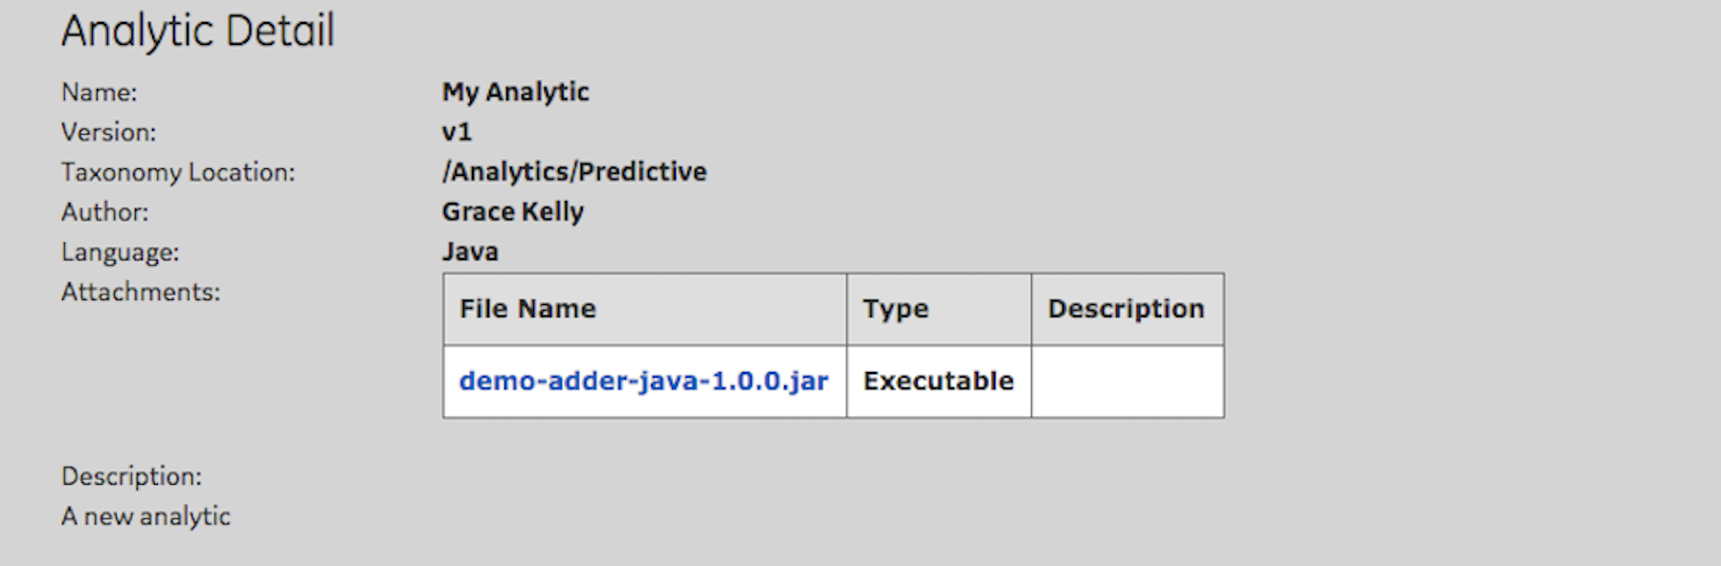

Name, Author, Version and Language are required fields.

***Note: After an analytic has been promoted to production use, you cannot update or delete its executable artifact, or validate the analytic.***

***\*\****The Status field will cycle through QUEUED, PROCESSING, or COMPLETED. Once the status returns COMPLETED the analytic is deployed to production.

1. **APP SERVICES:**

**5.1 Views**

Use this service to control the layout and components within your client-side web or mobile app. The View Service helps you create relationships between your Views, Cards, and asset classifications.

* **Component** – User-interface element that allows you to add features or access services following consistent UX practices, standards and specification.
* **Card** – Container that resides within the content area of the user interface. You can create interactions between components within an individual card, as well as interactions with other cards based on user [context](https://www.predix.io/docs/?r=46195#dViypQw).
* **Deck** – Container that supplies simple one-dimensional layout control for cards and components arranged in a specified order. This control can originate from the deck itself.
* **View** – Visual summary of the information displayed in a web application. It consists of one or more decks that an application user can select at runtime to quickly digest information and take appropriate action.

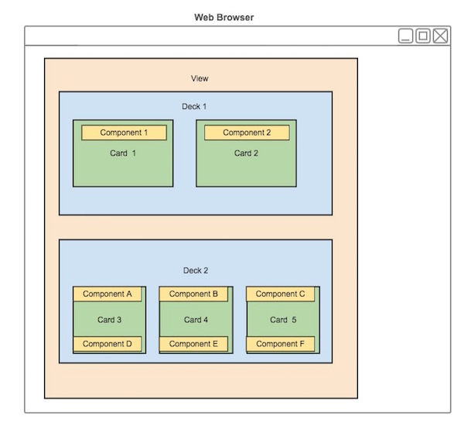

## Card CRUD Operations

**\*\*CRUD Operation on Card**

| **HTTP Method** | **Path** | **Description** |
| --- | --- | --- |
| GET | /api/cards | Get all cards. |
| POST | /api/cards | Create cards. |
| PUT | /api/cards/Id | Update card Id. |
| DELETE | /api/cards/Id | Delete card Id. |

**\*\*CRUD Operation on Deck**

| **HTTP Method** | **Path** | **Description** |
| --- | --- | --- |
| GET | /api/decks | Get all decks. |
| POST | /api/decks | Create decks. |
| PUT | /api/decks/Id | Update specified deck. |
| DELETE | /api/decks/Id | Delete specified deck. |

**\*Associating Cards & Deck**

| **HTTP Method** | **Path** | **Description** |
| --- | --- | --- |
| POST | /api/decks/Id/cards/add | Associate a card Id with a deck. |
| POST | /api/decks/Id/cards/remove | Detach a card Id from a deck. |
| GET | /api/decks/Id/cards | Get all cards in a deck. |
| POST | /api/decks/Id/cards/ordered | Set the card order in a deck. |

**\*\*Tagging Cards & Decks**

| **HTTP Method** | **Path** | **Description** |
| --- | --- | --- |
| POST | /api/cards/Id/tag | Tag a card. |
| POST | /api/decks/Id/tag | Tag a deck. |
| GET | /api/cards/tag?values={comma delimited tag strings} | Get all cards with tag strings. |
| GET | /api/decks/tag?values={comma delimited tag strings} | Get all decks with tag strings. |

Login in Cloud Foundry

cf login -a <API_Endpoint>

Create a View Service Instance

cf create-service predix-views <plan> <view__instanceID> -c '{"trustedIssuerIds":["<uaainstance1host>/oauth/token", "<uaainstance2_host>/oauth/token"]}'

1. [Create a card instance](https://www.predix.io/docs/?r=290504#yqhIrdjh) in the View service database. For example:
   1. Add a card to the <body> section of the HTML page of your web application. For example:

<!-- a card that can display temperature of a city -->

<my-temperature-card id="card-1" title="San Ramon Temperature" postal="94582" unit="F"></my-temperature-card>

* 1. In a REST client, enter the following POST request:

[POST] /api/cards

* 1. Copy the following JSON blocks into the request body:

[{

"title": "San Ramon Temperature",

"slug": "my-temperature-card",

"attributes": {

"postal": "94582",

"unit": "F"

}

}]

1. [Create a deck instance](https://www.predix.io/docs/?r=290497#yqhIrdjh) in the View service database. For example:
   1. Add a deck to the <body> section of the HTML page of your web application:

<!-- a deck with 2 cards -->

<px-deck id="deck-1">

<my-temperature-card id="card-1" title="San Ramon Temperature"postal="94582" unit="F"></my-temperature-card>

<my-temperature-card id="card-3" title="Walnut Creek Temperature" postal="94595" unit="F"></my-temperature-card>

</px-deck>

* 1. In a REST client, enter the following POST request:

[POST] /api/decks

* 1. Copy the following JSON blocks into the request body:

{

"title": "Contra Costa Deck"

"cardOrder": [{

"title": "San Ramon Temperature",

"slug": "my-temperature-card",

"attributes": {

"postal": "94582",

"unit": "F"

}

},

{

"title": "Walnut Creek Temperature",

"slug": "my-temperature-card",

"attributes": {

"postal": "94595",

"unit": "F"

}

}]

"id": "deck-1"

}

1. [Tag a deck](https://www.predix.io/docs/?r=290484#yqhIrdjh) to group by multiple values. For example:
   1. Enter the following POST request:

[POST] /api/decks/1/tags

* 1. Copy the following JSON blocks into the request body:

[

{"value": "contra costa"},

{"value": "california"},

{"value": "us"}

]

1. [Look up a deck](https://www.predix.io/docs/?r=290483#yqhIrdjh) by tag. For example:
   1. Enter the following GET request:

[GET] /api/decks/tags?values=us

* 1. Copy the following JSON blocks into the request body:

[

{

"id": 1,

"title": "Contra Costa Deck"

"tags": [

{"value": "contra costa"},

{"value": "california"},

{"value": "us"}

]

}

]

**Filters**

?filter[<filterType>]=[<filter inputs>]

| Table 1. Supported Filters | | |
| --- | --- | --- |
| **Filter Type** | **Description** | **Example** |
| Include | Allow related data models to be included in the result set | /decks?filter[include]=cards |
| Order | Allow result set to be return in order that is specified | /decks?filter[order]=createTimeStamp DESC |
|  | Get a deck with ordered cards | decks?filter[cards] &filter[order]=cards |
| Where | Filter the result set by field value | /decks?filter[where][title]=Overview |

1. **Predix UI Seed**

The Predix UI Seed is a web application starter kit that demonstrates the use of the Predix UI platform to implement the following features:

* Application Navigation
* Responsive Layout
* Routing
* Data Binding
* View Switching
* Data Visualization
* Date and Time Input
* Service Integration

The Predix UI Seed does not depend on any Predix service to deploy to your local development environment or Cloud Foundry.

## Installing the Predix UI Seed

**\*\*Install the Predix UI Seed to the local developer environment.**

This procedure uses the following developer tools to install the Predix UI Seed:

* Node.js npm package-management utility.
* gulp command-line interface for npm.
* gulp serve plugin for starting a web server that runs tasks and serves files.
* bower front end package manager for npm.

1. To clone your copy of the Predix UI Seed and start a Predix UI Seed project, at a command prompt, enter

git clone https://github.com/PredixDev/predix-seed.git

1. To change to the predix-seed project directory, at a command prompt, enter:

cd predix-seed

1. To install the gulp build system and bower front end package manager, at a command prompt, enter:

npm install gulp gulp-cli bower -g

1. To install the Predix UI Seed dependencies for these utilities, at a command prompt enter

npm install

bower install

The package.json file lists the build-time dependencies.

The bower.json file lists the run-time dependencies.

1. To verify that the Predix UI Seed files have been successfully installed:, at a command prompt, enter

gulp

***Note: During normal development, run the gulp dist command each time before you perform the cf push operation to deploy yourPredix UI Seed web application to Cloud Foundry.***

**Few more repeated things if you wish to go???**

## [Scopes authorized by the UAA](https://github.com/GESoftware-CF/uaa/blob/master/docs/UAA-APIs.rst#id13)

The UAA itself is also performing authorization based on the scope claim in the JWT token for it's operation. Here is a summary of the different scopes that are known to the UAA.

* **zones.read** - scope required to invoke the /identity-zones endpoint to read identity zones
* **zones.write** - scope required to invoke the /identity-zones endpoint to create and update identity zones
* **idps.read** - read only scopes to retrieve identity providers under /identity-providers
* **idps.write** - create and update identity providers under /identity-providers
* **clients.admin** - super user scope to create, modify and delete clients
* **clients.write** - scope required to create and modify clients. The scopes are limited to be prefixed with the scope holder's client id. For example, id:testclient authorities:client.write may create a client that has scopes that have the 'testclient.' prefix. Authorities are limited to uaa.resource
* **clients.read** - scope to read information about clients
* **clients.secret** - /oauth/clients/*/secret endpoint. Scope required to change the password of a client. Considered an admin scope.
* **scim.write** - Admin write access to all SCIM endpoints, /Users, /Groups/.
* **scim.read** - Admin read access to all SCIM endpoints, /Users, /Groups/.
* **scim.create** - Reduced scope to be able to create a user using POST /Users (get verification links GET /Users/{id}/verify-link or verify their account using GET /Users/{id}/verify) but not be able to modify, read or delete users.
* **scim.userids** - /ids/Users - Required to convert a username+origin to a user ID and vice versa.
* **scim.zones** - Limited scope that only allows adding/removing a user to/from [zone management groups](https://github.com/GESoftware-CF/uaa/blob/master/docs/UAA-APIs.rst#zone-management-groups) under the path /Groups/zones
* **scim.invite** - Scope required by a client in order to participate in invitations using the /invite_users endpoint.
* **password.write** - /User*/*/password endpoint. Admin scope to change a user's password.
* **oauth.approval** - /approvals endpoint. Scope required to be able to approve/disapprove clients to act on a user's behalf. This is a default scope defined in uaa.yml.
* **oauth.login** - Scope used to indicate a login application, such as external login servers, to perform trusted operations, such as create users not authenticated in the UAA.
* **approvals.me** - not currently used
* **openid** - Required to access the /userinfo endpoint. Intended for OpenID clients.
* **groups.update** - Allows a group to be updated. Can also be accomplished with scim.write
* **uaa.user** - scope to indicate this is a user, also required in the token if using API Authorization Requests Code: ``GET /oauth/authorize` (non standard /oauth/authorize)`_
* **uaa.resource** - scope to indicate this is a resource server, used for the /check_token endpoint
* **uaa.admin** - scope to indicate this is the super user
* **uaa.none** - scope to indicate that this client will not be performing actions on behalf of a user

**Zone Management Scopes**

* **zones.<zone id>.admin** - scope that permits operations in a designated zone by authenticating against the default zone, such as create identity providers or clients in another zone (used together with the X-Identity-Zone-Id header)
* **zones.<zone id>.read** - scope that permits reading the given identity zone (used together with the X-Identity-Zone-Id header)
* **zones.<zone id>.clients.admin** - translates into clients.admin after zone switch is complete (used together with the X-Identity-Zone-Id header)
* **zones.<zone id>.clients.read** - translates into clients.read after zone switch is complete (used together with the X-Identity-Zone-Id header)
* **zones.<zone id>.clients.write** - translates into clients.write after zone switch is complete (used together with the X-Identity-Zone-Id header)
* **zones.<zone id>.scim.read** - translates into scim.read after zone switch is complete (used together with the X-Identity-Zone-Id header)
* **zones.<zone id>.scim.create** - translates into scim.create after zone switch is complete (used together with the X-Identity-Zone-Id header)
* **zones.<zone id>.scim.write** - translates into scim.write after zone switch is complete (used together with the X-Identity-Zone-Id header)
* **zones.<zone id>.idps.read** - translates into idps.read after zone switch is complete (used together with the X-Identity-Zone-Id header)

Common Request Headers

| **Header** | **Description** | **Operations** |
| --- | --- | --- |
| **Authorization\*** | Authenticates the requester. | All |
| **Host\*** | Host URI | All |
| **Date\*** | Requester date and time, for example,Tues, 14 Jun 2011 08:30:00 GMT. | All |
| **Content-Length\*** | Message length (without headers) | All |
| **Content-MD5** | Integrity check specifying a base64 encoded, 128-bit MD5 hash of the message without its headers, used to determine that the original data is returned unchanged. | PUT Object  PUT Object acl |
| **Content-Type** | Resource content type, for example, text/plain.  ***Note: For PUT operations, default is binary/octet-stream, and valid values are MIME types.*** | All |
| **Cache-control** | Specifies directives that may override existing caching mechanisms and prevent caches from interfering with the HTTP request or response. | All |
| **Expect** | Requests an acknowledgment before sending the message body when the sending application issues a 100-continue message; body not sent when its headers are refused. | PUT Object  PUT Object acl |
|  |  |  |
| **Range** | Requests the range bytes of an object. | GET Object  Head Object |
| **x-amz-date** | May be used in place of the HTTP Date header. If this header is present, an empty string is used for the date header in the StringToSign. The timestamp sent by the client must be within a 15 minute range of the server System Time. Otherwise, the request fails. | All |
| **x-amz-meta** | Metadata to be stored and returned with an object. The size of the HTTP request excluding the message body cannot exceed 8KB. | PUT Object  PUT Object acl |

* Authorization Code – Direct UAA before granting token
* Implicit – No Authentication Issues Token on Request
* Resource Owner Password – Accepts User Name/Password
* Refresh Token – Refreshes Token on Expiry
* Client Credentials – Accepts Client Id and Client Secret to issue tokens

=>Service to Service Communication – Client Credentials

=>WebApp – AuthorizationCode

**Training Session Slides:**

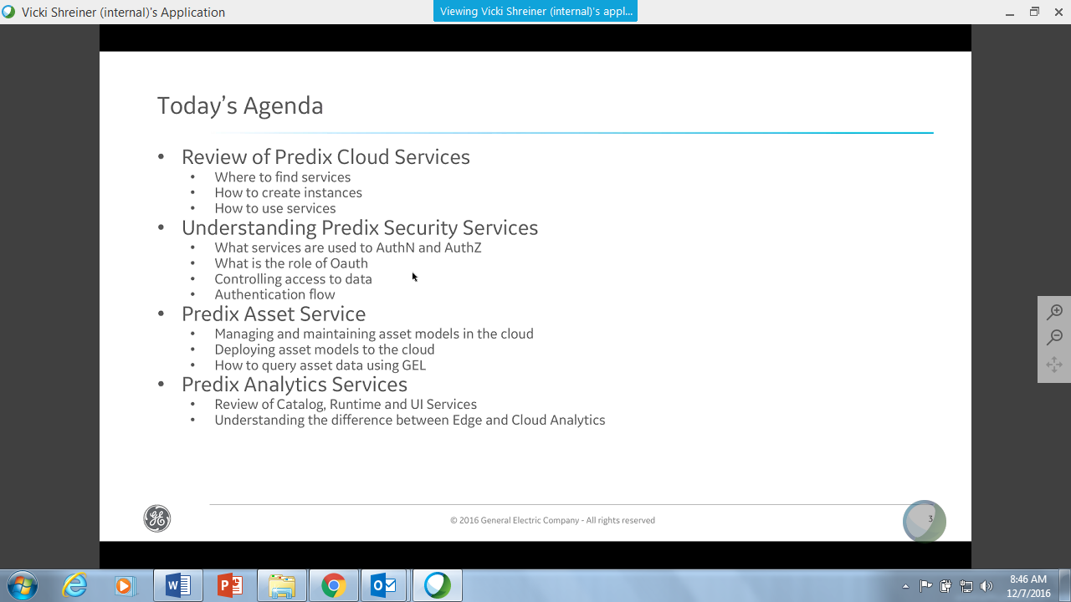

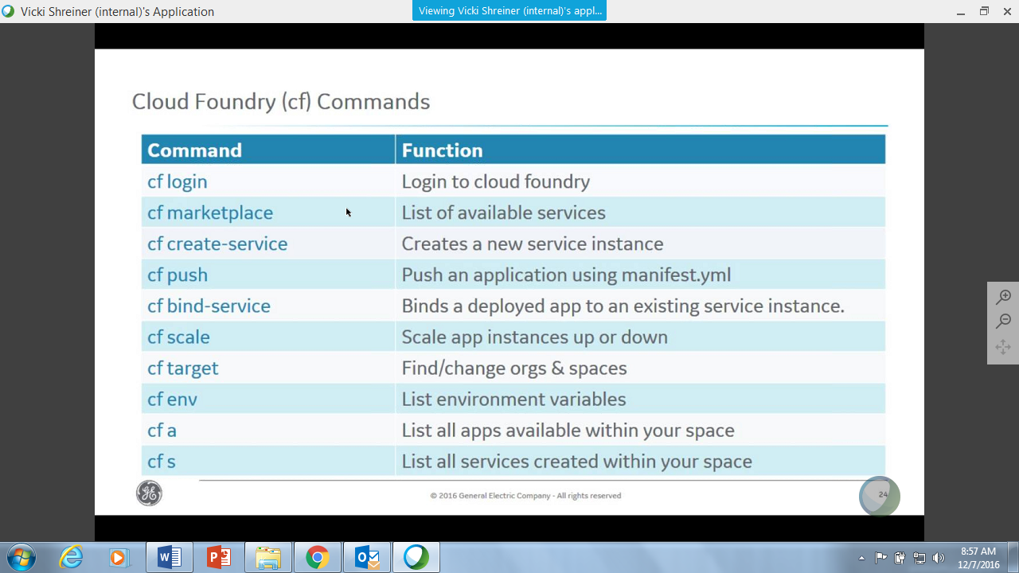

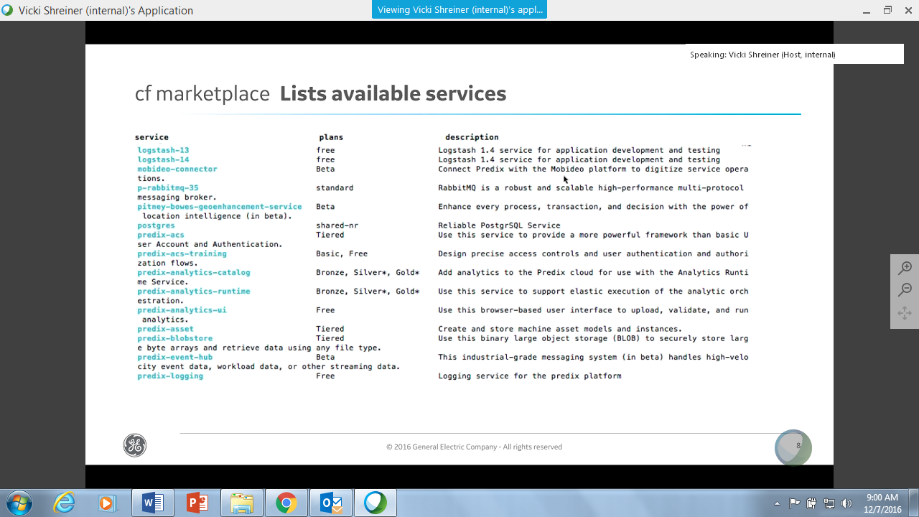

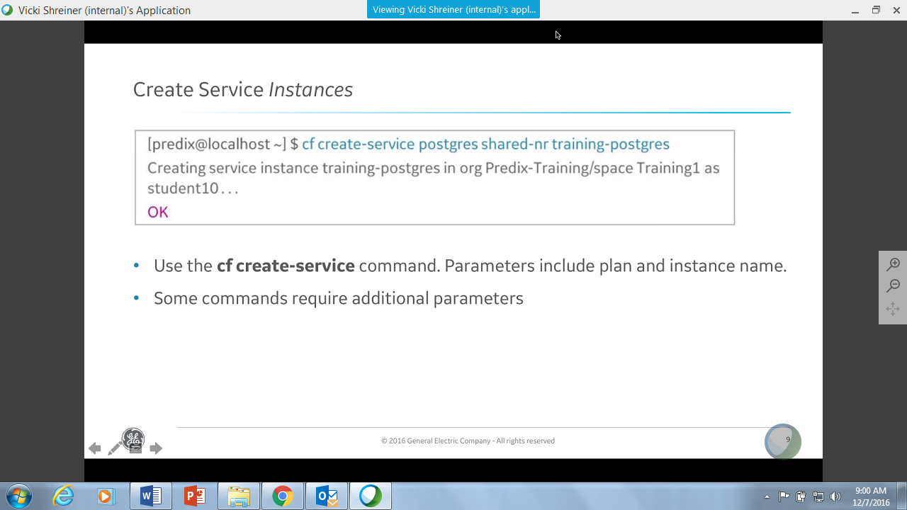

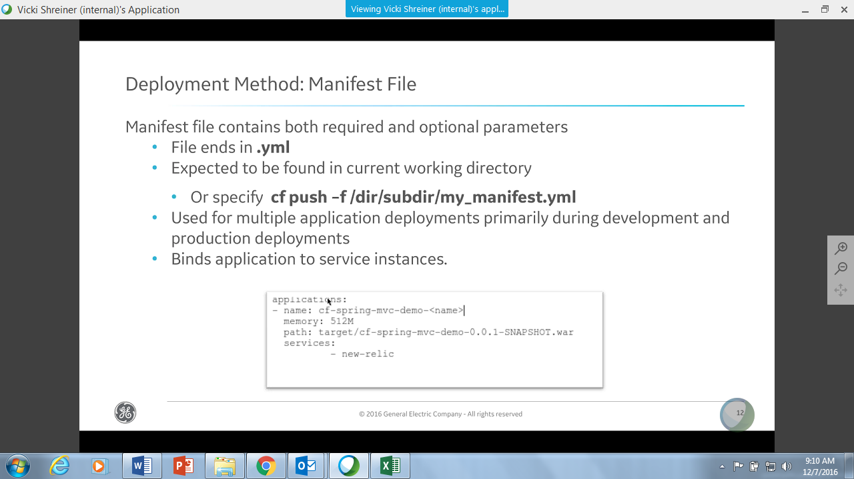

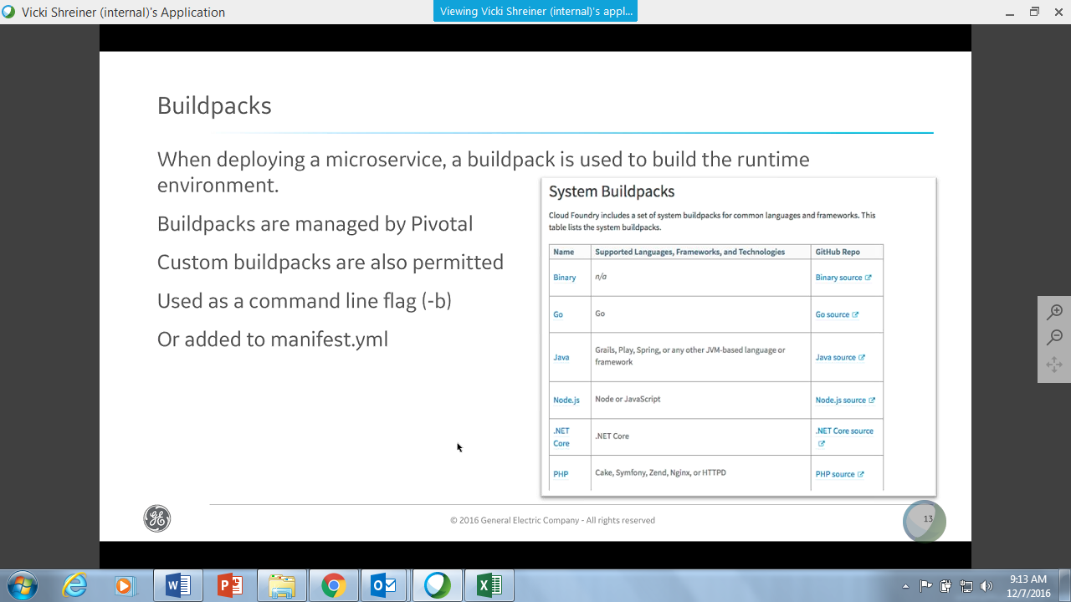

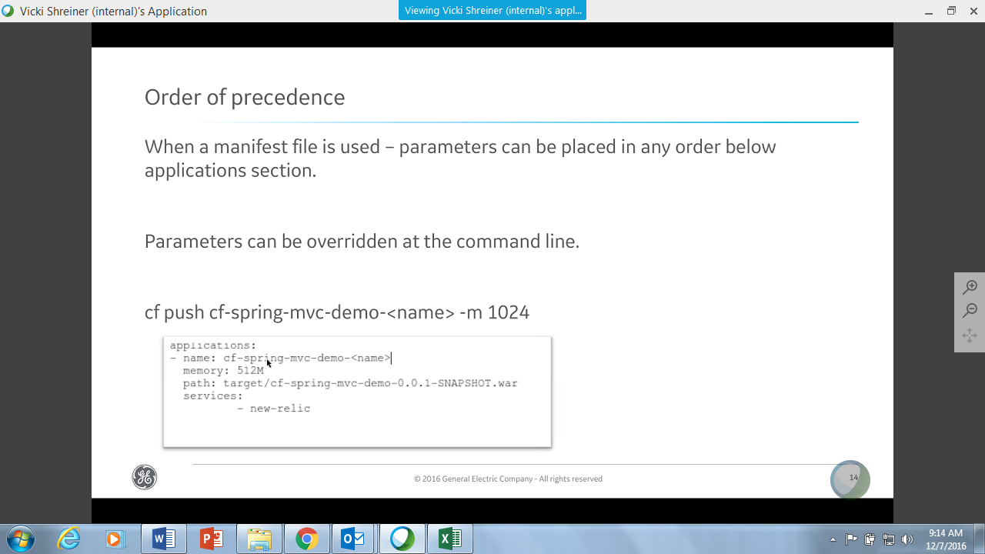

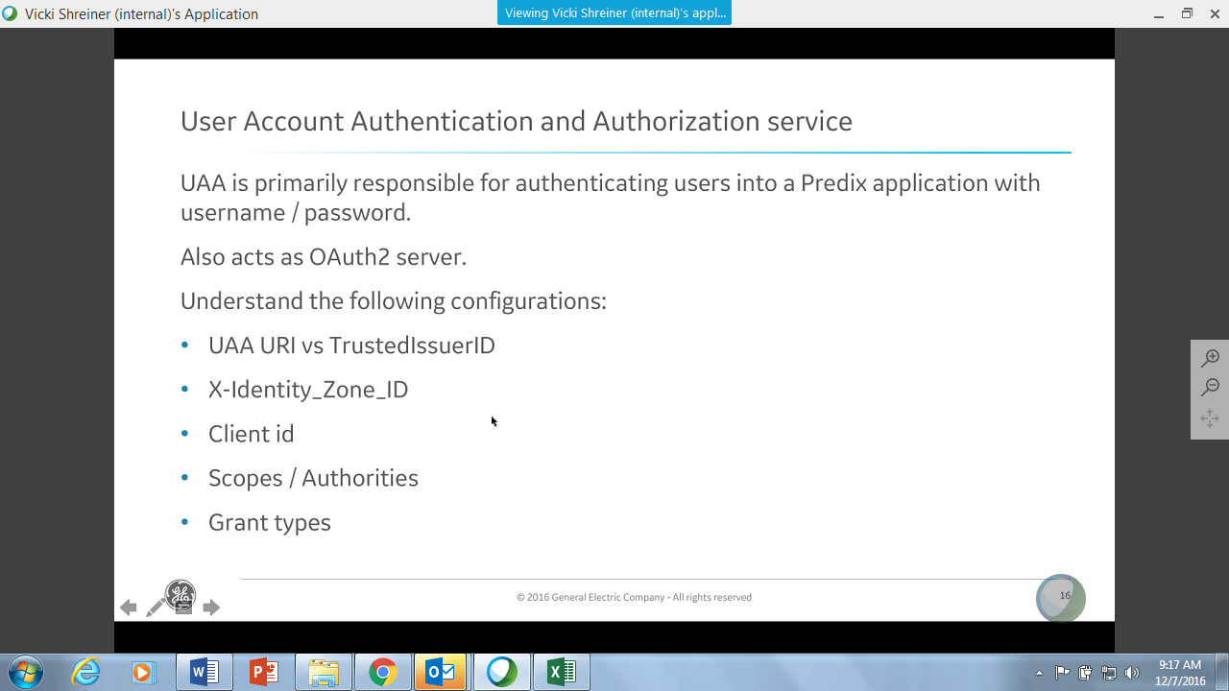

Token - Intersection user rights and app rights

Grant Type – Authorization Code

ACS – Authorize Apps and not Users

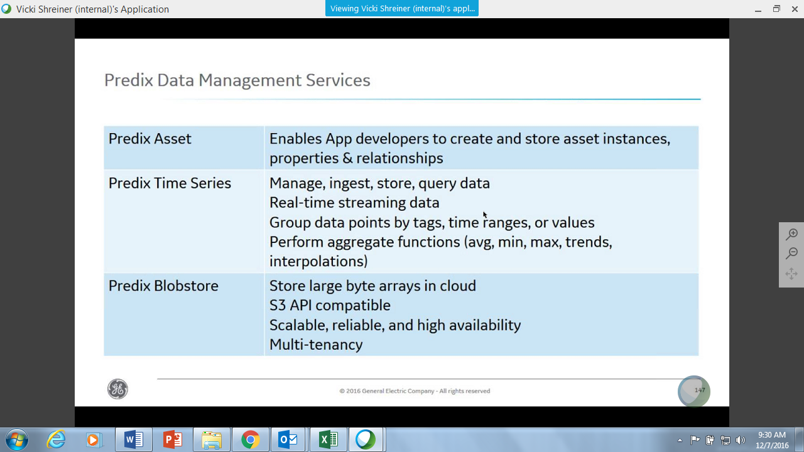

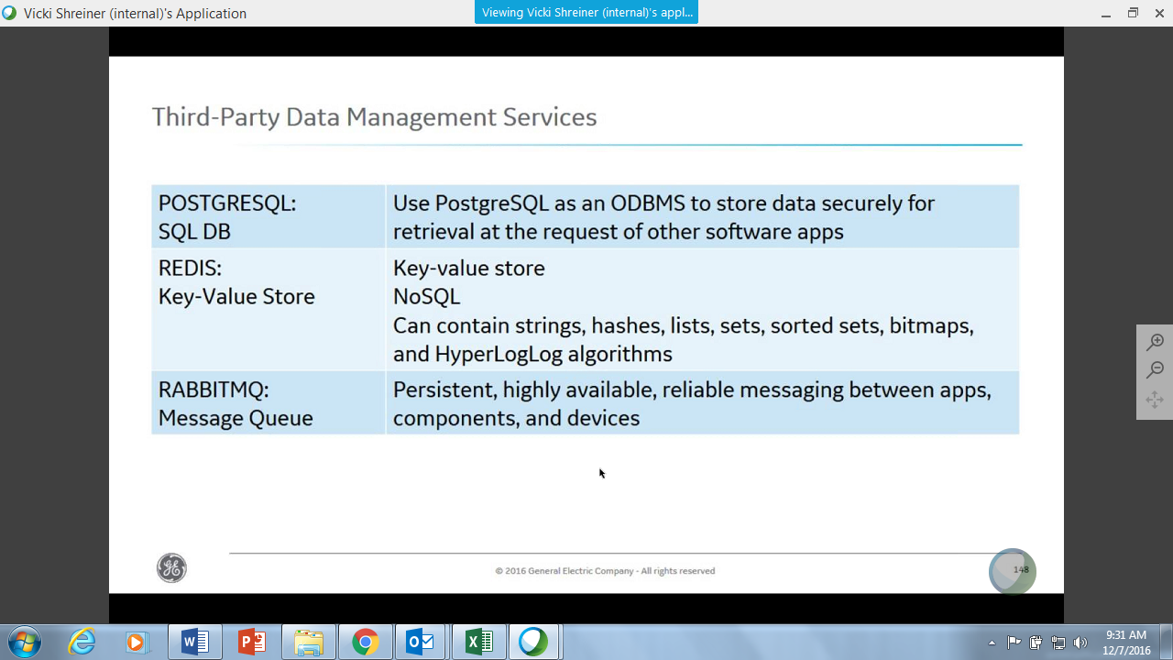

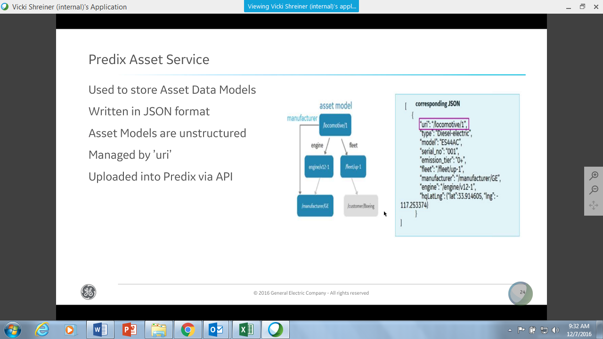

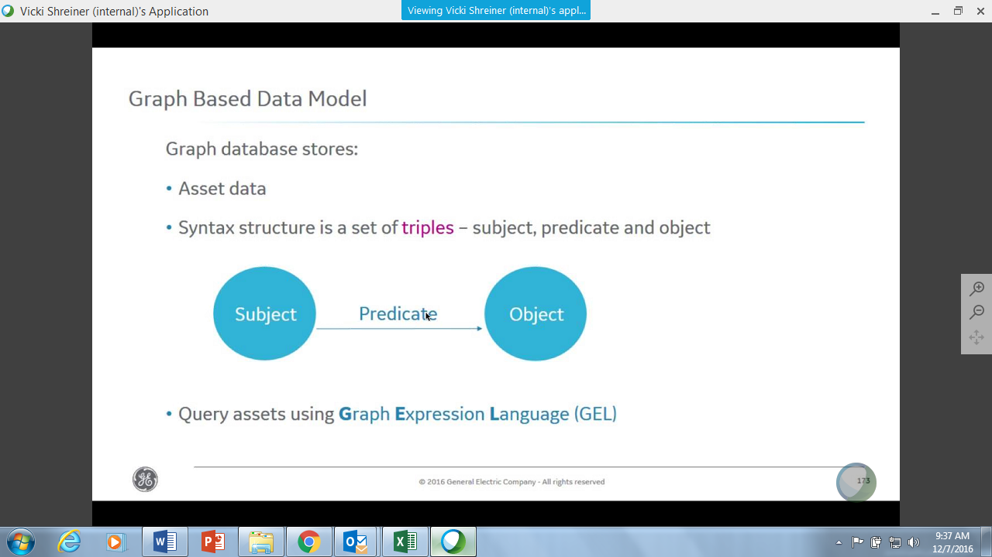

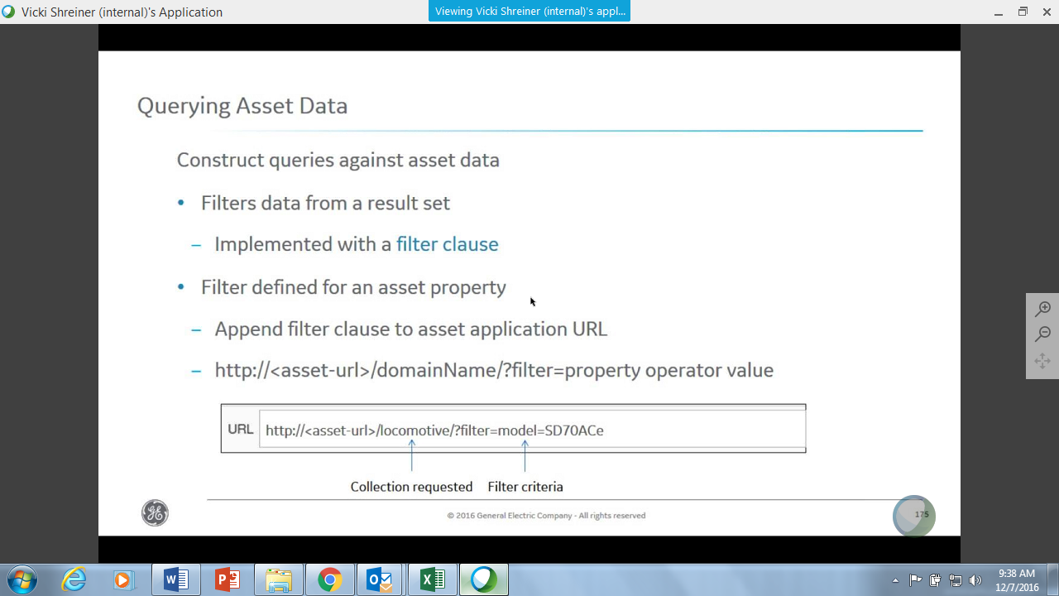

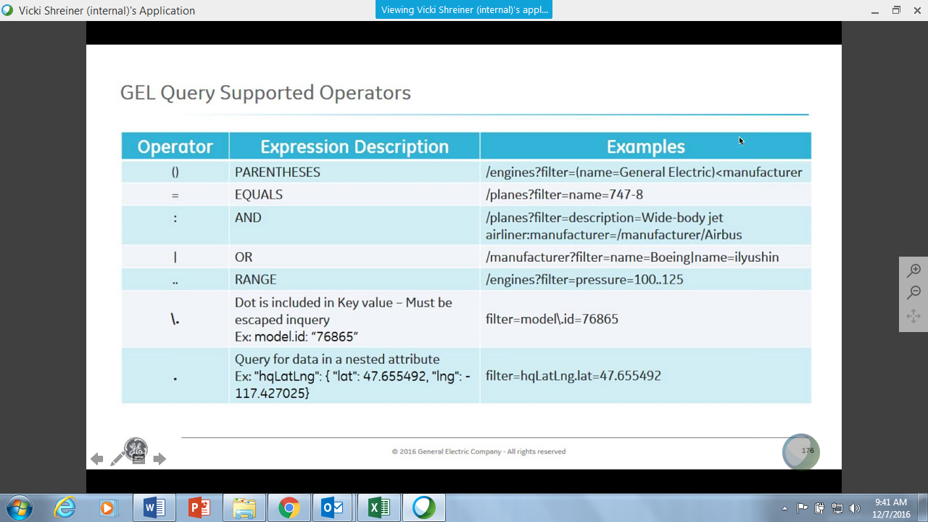

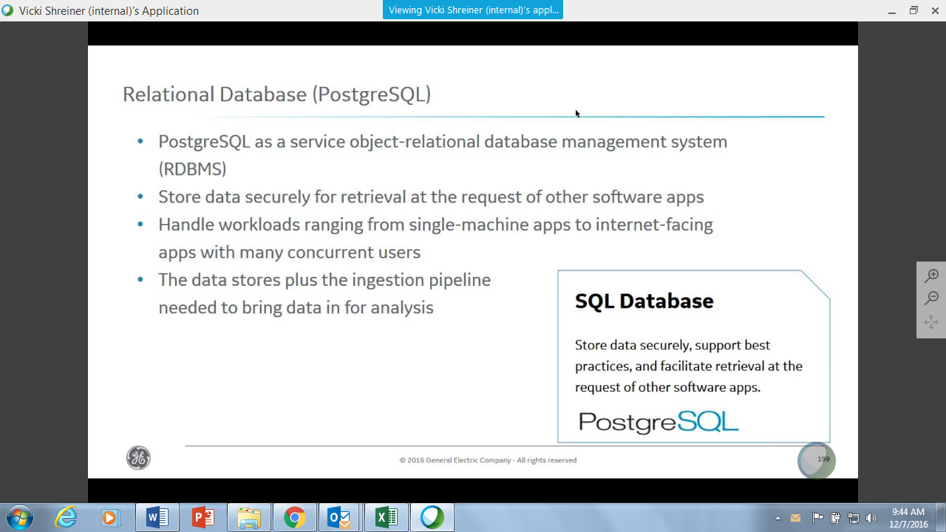

GEL Queries

